O&M Billing Module

(Low Level Design Document &
High Level Design Document)



M.P. STATE ELECTRONICS DEVELOPMENT CORPORATION LTD.
State IT Centre, 47-A, Arera Hills, Bhopal-462011 (M.P.)
www.mpsedc.mp.gov.in

Version | Date | Description | Prepared By | Reviewed By
1.0 | 14-10-2025 | First baseline version | Development | PM
1.1 | 11-12-2025 | Process view section added | Development | PM

Table of Contents
1.EXECUTIVE SUMMARY 3
2. SYSTEM ARCHITECTURE 3
3. ENTITY RELATIONSHIP DIAGRAM (ERD) 5
4. SEQUENCE DIAGRAMS 8
5. COMPLETE CLASS DIAGRAMS 11
6. Detail Database Design 15
7. API CONTRACTS 16
8. BUSINESS LOGIC 18
9. SECURITY DESIGN 19
10. SECURITY DESIGN ARCHITECTURE 20
11. ERROR HANDLING & VALIDATION ARCHITECTURE 27
12. PERFORMANCE OPTIMIZATION & DEPLOYMENT CHECKLIST 31
13. PROJECT IMPLEMENTATION ROADMAP 34
14. RISK MANAGEMENT PLAN 36
16. FUTURE ENHANCEMENT 37

EXECUTIVE SUMMARY
Project Overview
Parameter | Details
Project Name | O&M Billing & Contract Management System
Client | Madhya Pradesh Jal Nigam Maryadit, GoMP
Technology Stack | ASP.NET MVC, PostgreSQL, Web API
Architecture | N-Tier with Repository Pattern
Deployment | Web Application with Role-Based Access
Key Features | Contract Management, SLBM Penalty Calculation, Multi-level Approval, Real-time Reporting

2. SYSTEM ARCHITECTURE
2.1 Architecture Diagram
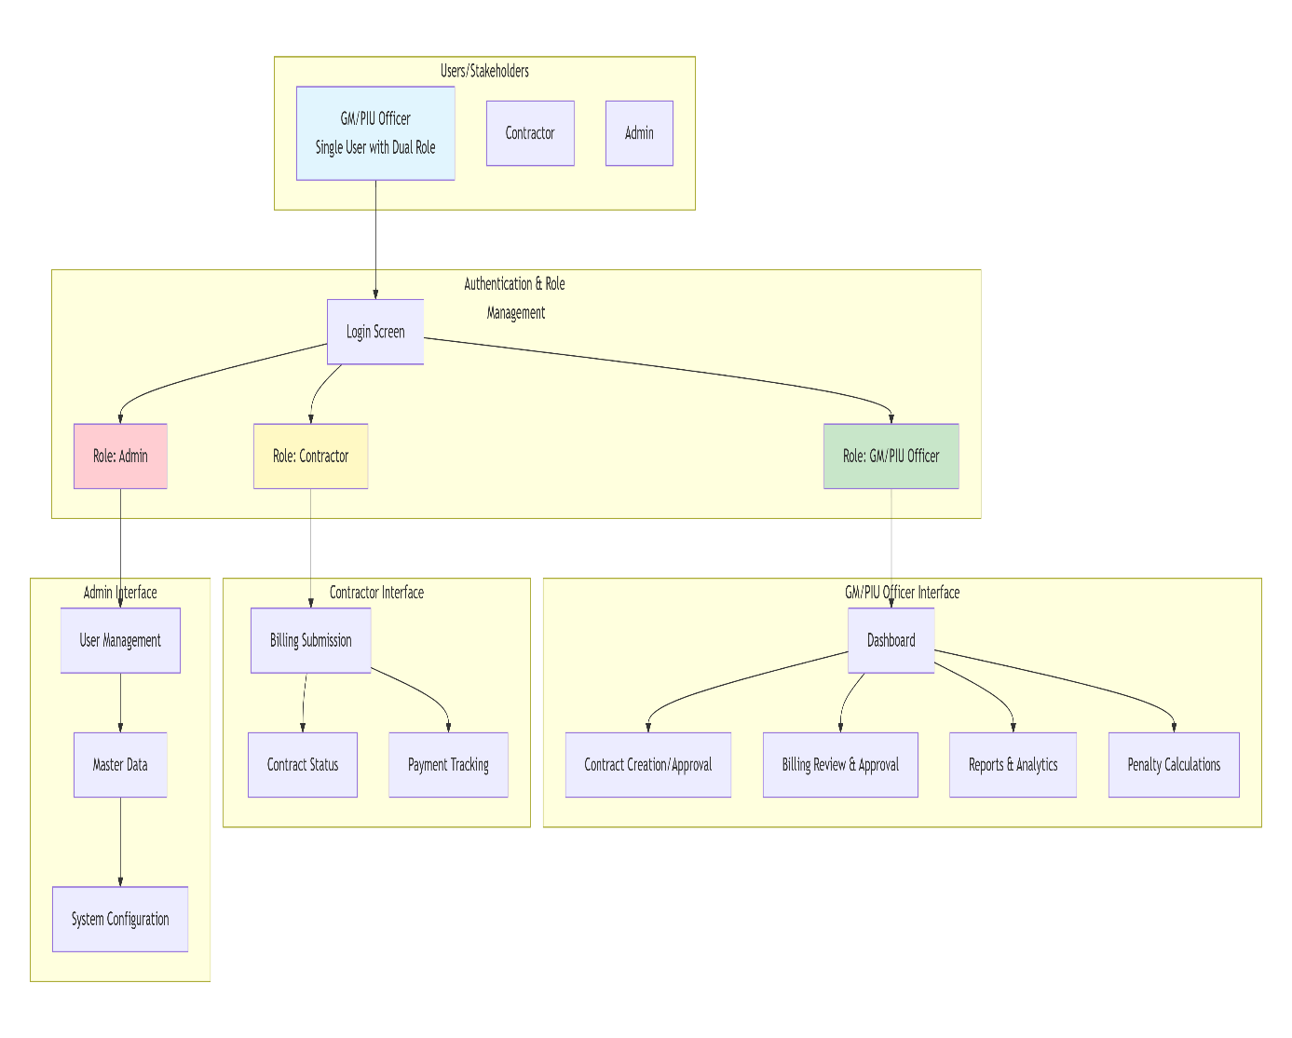

  - Role-Based Access Flow:
2.2.1 GM/PIU Officer (Single User)
- Dashboard:
- ├── Contract Management (Create/Edit/Approve)
- ├── Billing Approval (Review & Approve bills)
- ├── SLBM Penalty Calculation
- ├── Increment/CPI Adjustments
- ├── Reports & Analytics
- └── Performance Monitoring

    - Contractor
- Dashboard:
- ├── Submit New Bills
- ├── View Bill Status
- ├── Track Payments
- ├── View Contract Details
- └── Download Document

  - Technology Stack:
Layer | Technologies | Version
Frontend | ASP.NET MVC, Razor Views, Bootstrap 5, jQuery | .NET 6
API Layer | ASP.NET Web API, RESTful, JSON, Swagger | .NET 6
Business Logic | C#, Design Patterns, Validation Rules | .NET 6
Data Access | Entity Framework Core, Repository Pattern | EF Core 6
Database | PostgreSQL 14+, Stored Procedures, Views | 14+
Authentication | JWT, BCrypt, Role-Based Authorization | -
Logging | Serilog, NLog, Audit Trail | -
Deployment | IIS, Docker, Azure App Services | -

3. ENTITY RELATIONSHIP DIAGRAM (ERD)
3.1 Entity Relationship Diagram
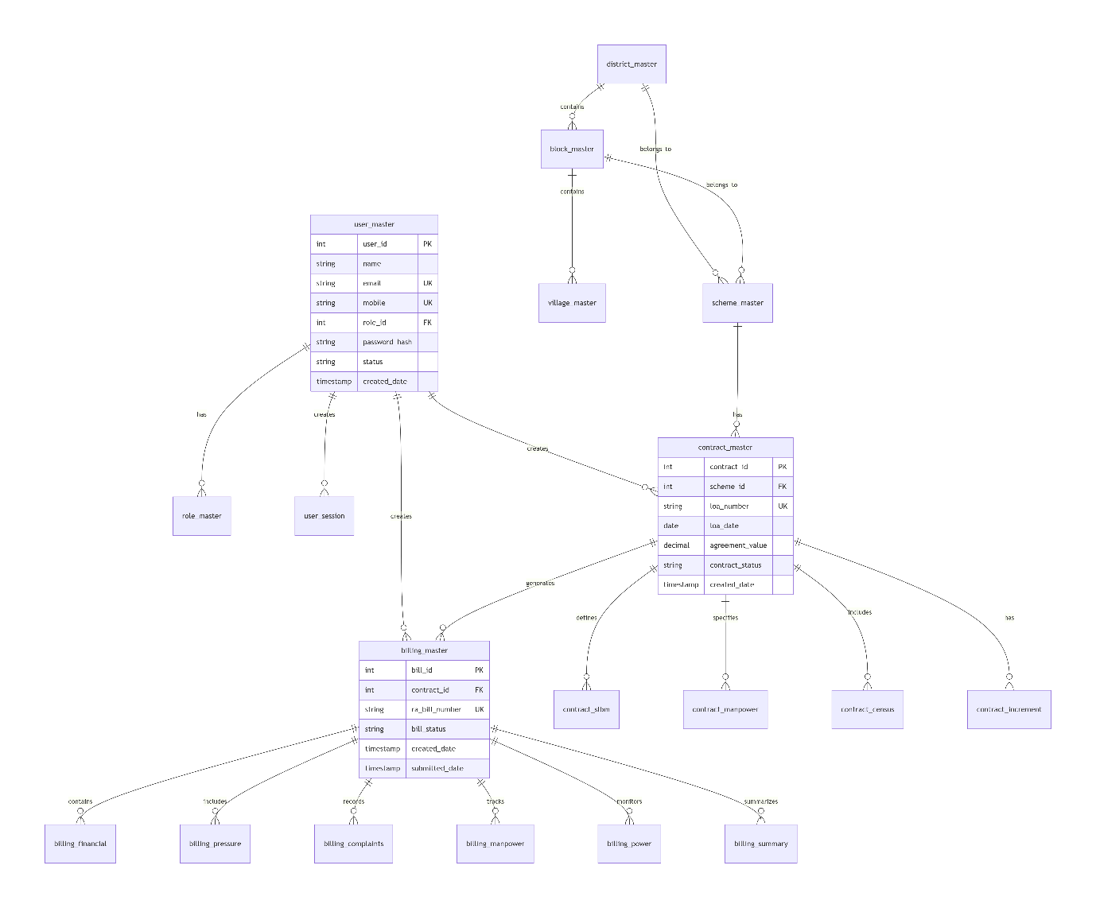
Key Responsibilities:
- User → Contract (1:N) - One user creates multiple contracts
- Contract → Billing (1:N) - One contract generates multiple bills
- Scheme → Contract (1:1) - One scheme has one active contract
- Contract → SLBM (1:N) - Multiple SLBM parameters per contract
- Bill → Summary (1:1) - Each bill has one summary

3.2 Data Flow Diagram
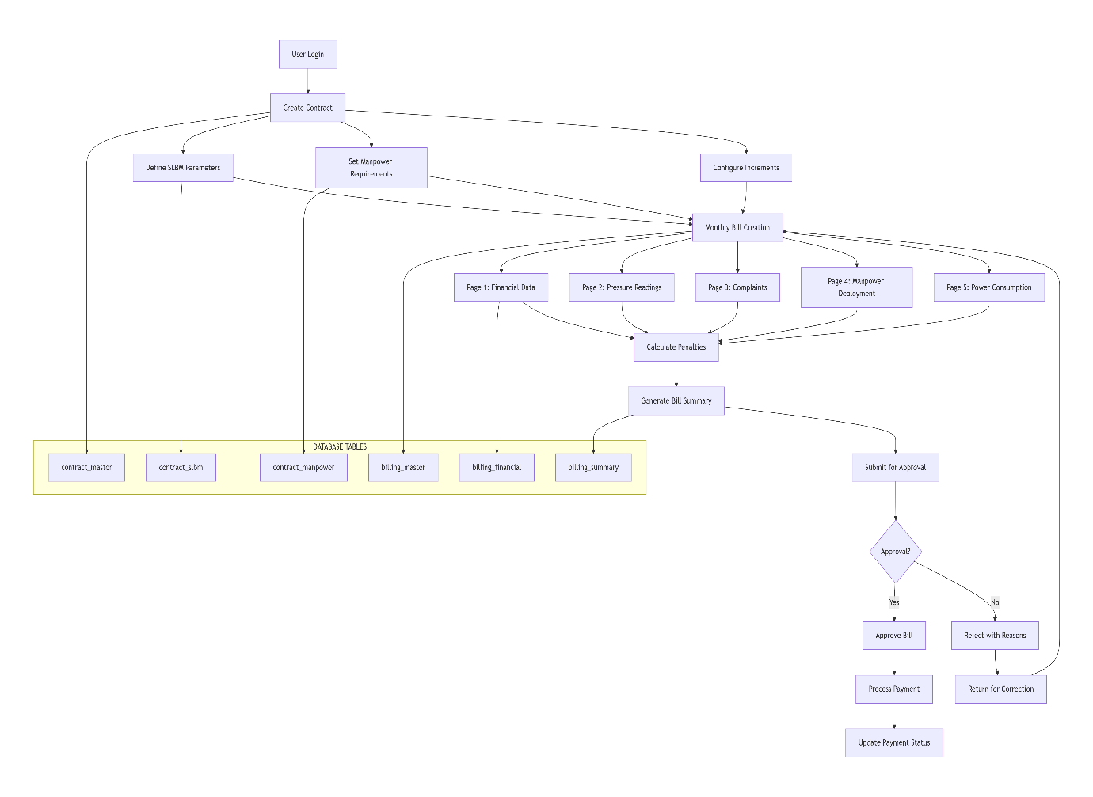

3.3 Table Relationship Matrix
Table | Related To | Relationship | Foreign Key
user_master | role_master | Many-to-One | role_id
user_master | contract_master | One-to-Many | contractor_id
scheme_master | contract_master | One-to-One | scheme_id
contract_master | contract_slbm | One-to-Many | contract_id
contract_master | billing_master | One-to-Many | contract_id
billing_master | billing_financial | One-to-One | bill_id
billing_master | billing_pressure | One-to-Many | bill_id
billing_master | billing_summary | One-to-One | bill_id
village_master | billing_pressure | One-to-Many | village_id

4. SEQUENCE DIAGRAMS
  - Complete Bill Submission Flow
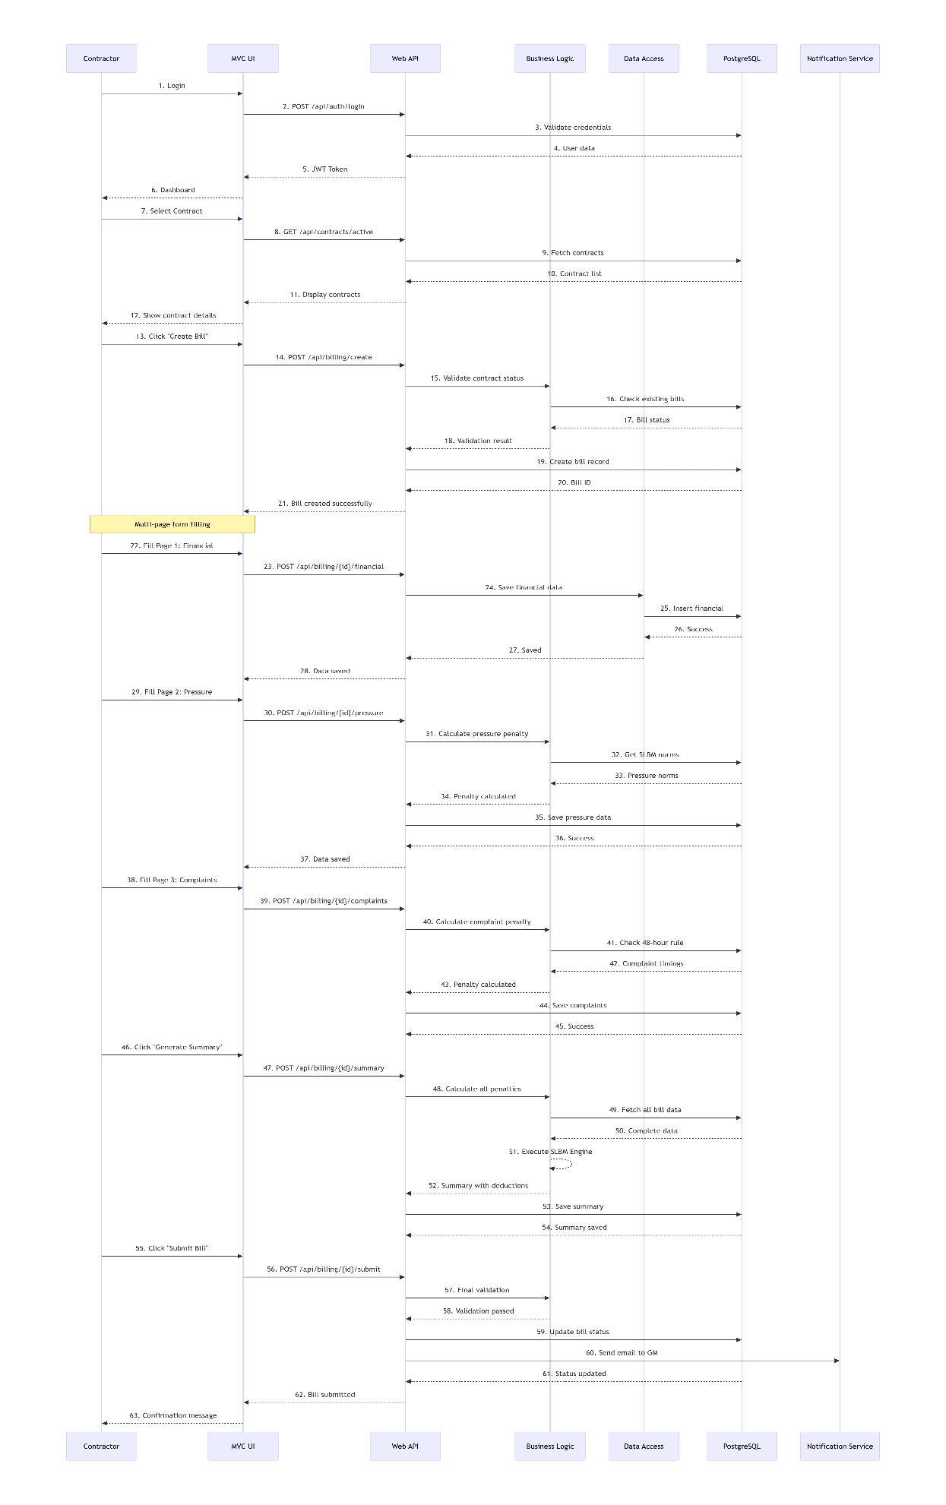
  - Complete Bill Submission Flow
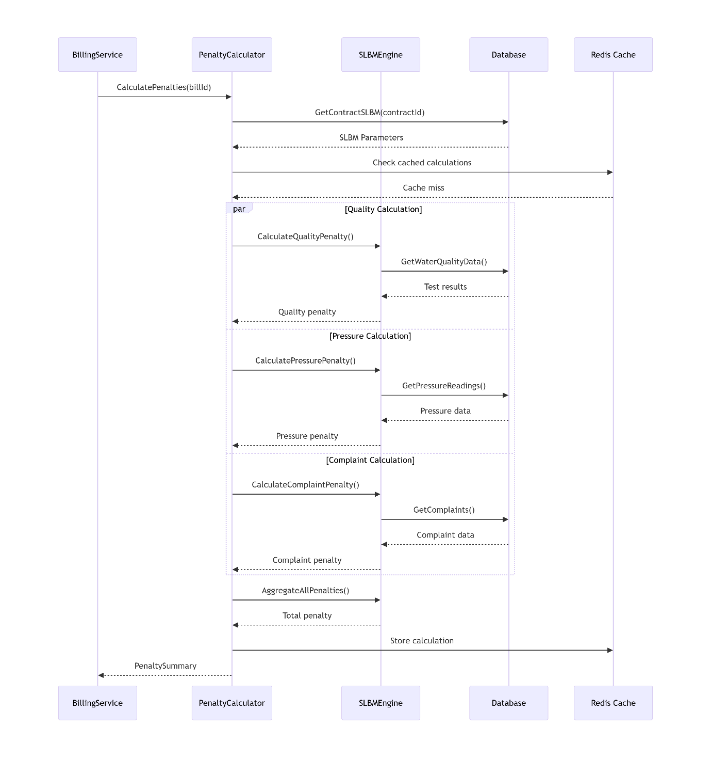

5. COMPLETE CLASS DIAGRAMS
  - Core Domain Models 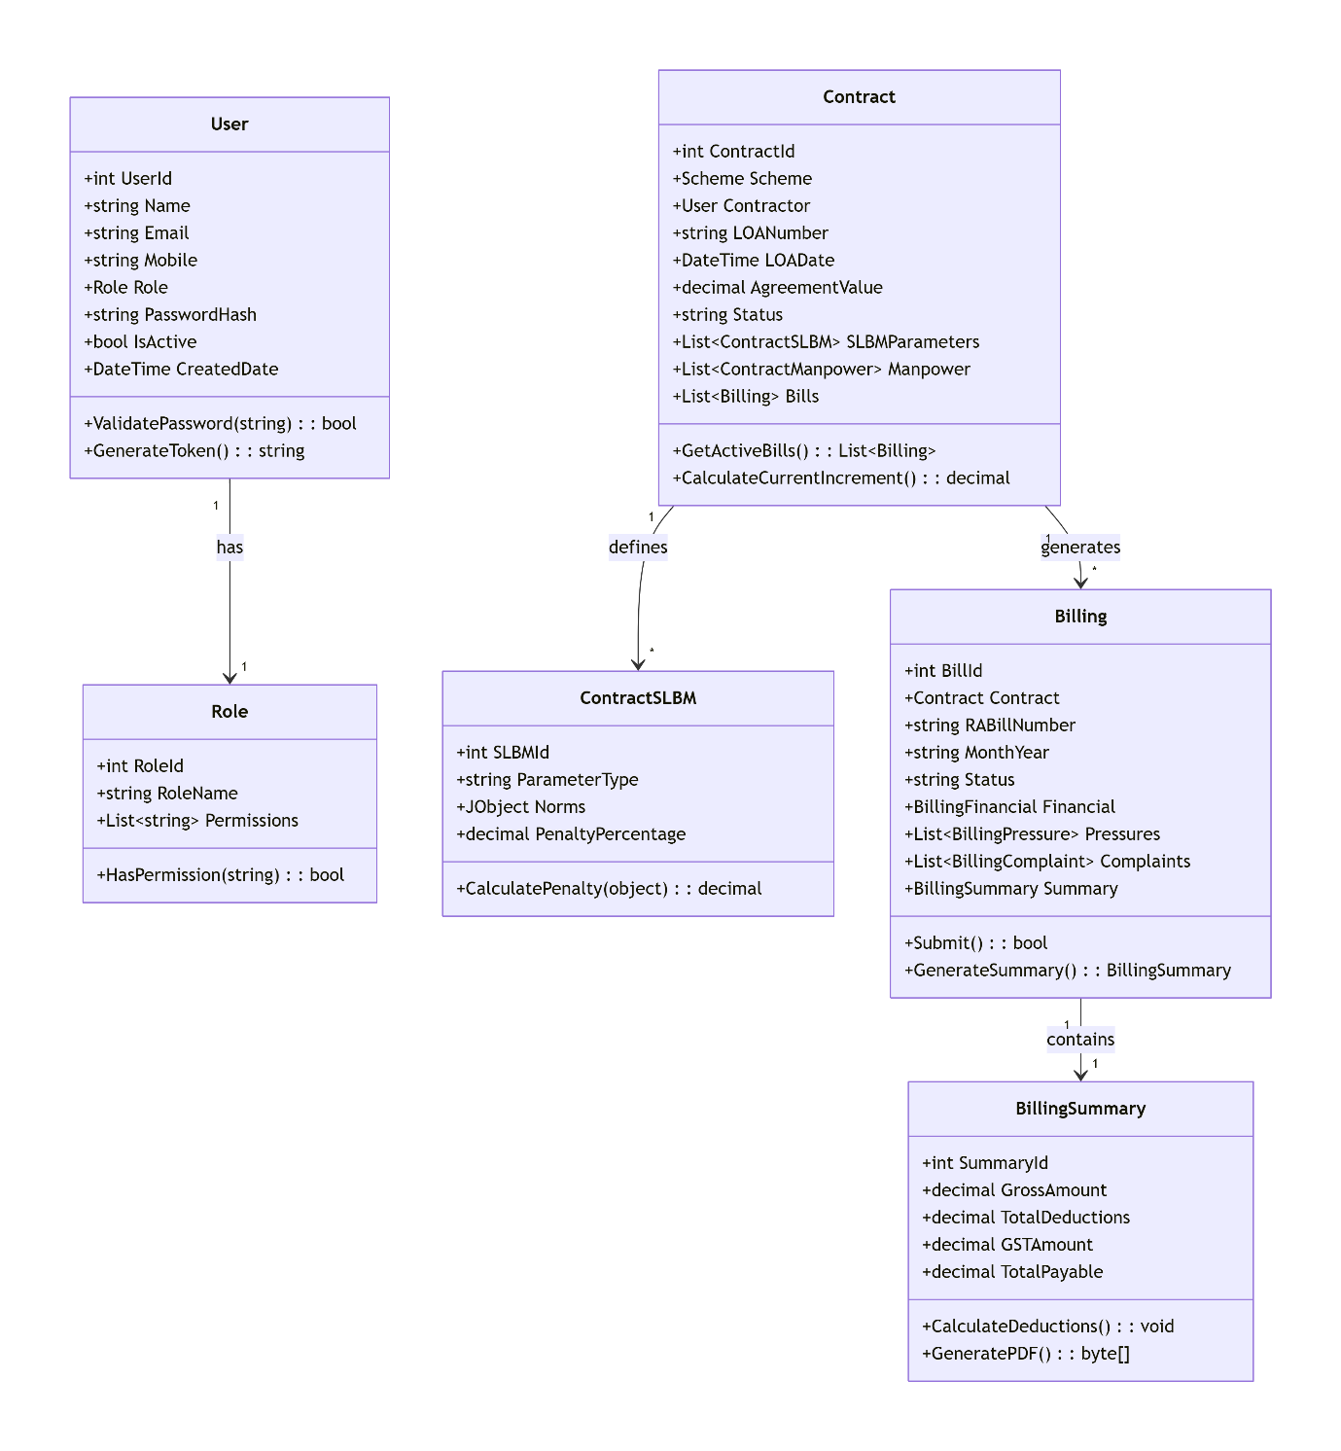

  - Service Layer Architecture
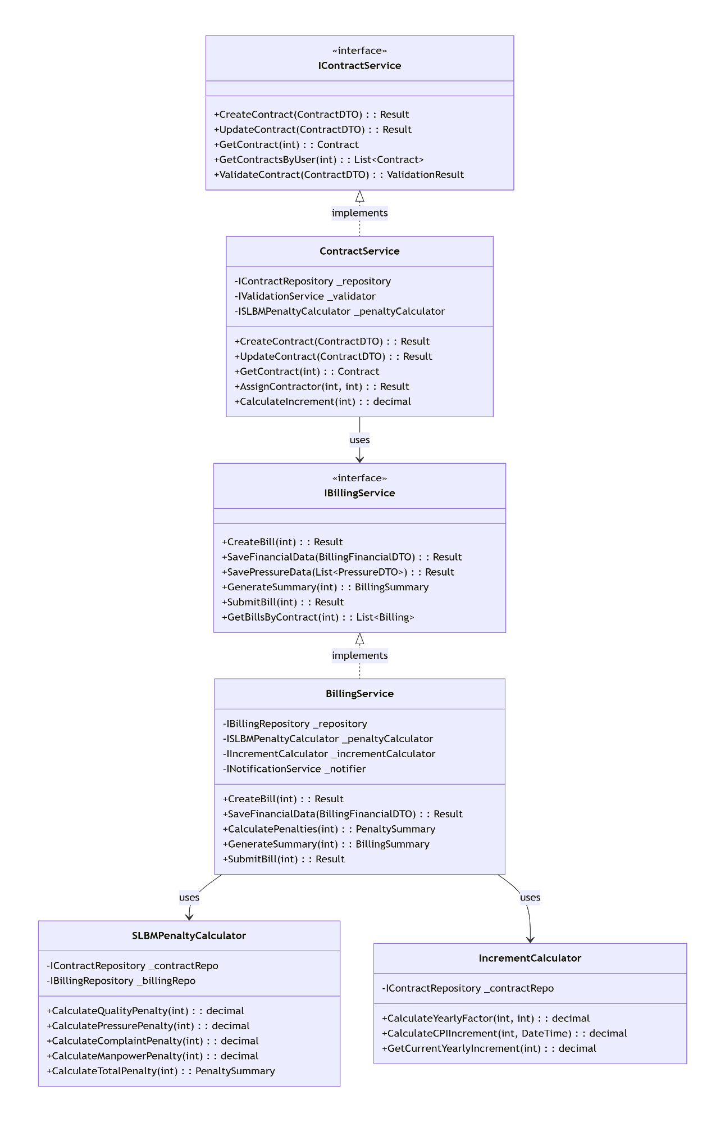

  - Service Layer Architecture Diagram
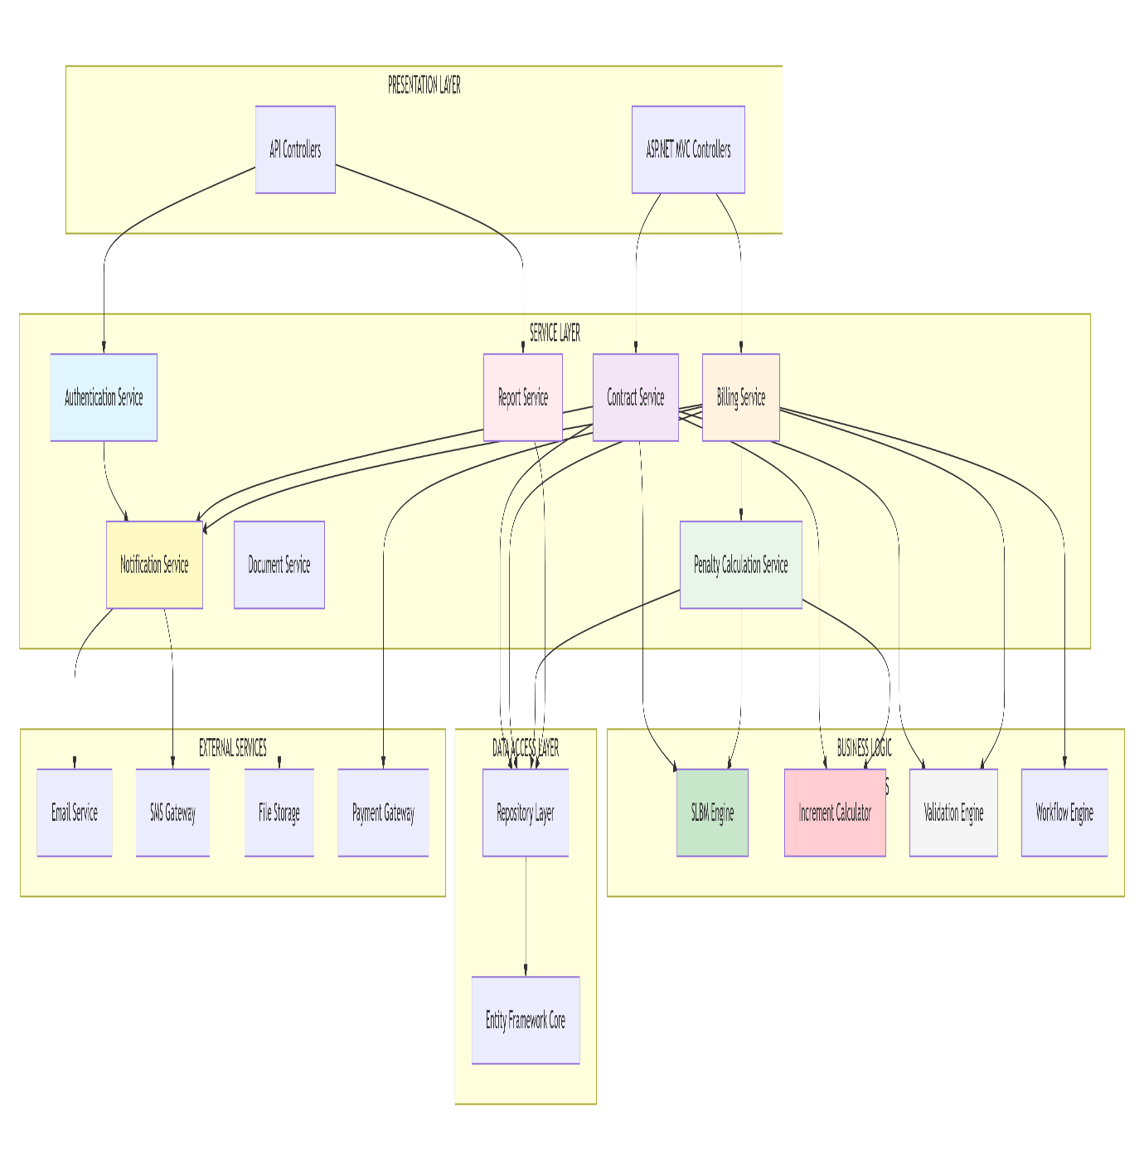

6. Detail Database Design
6.1 Complete DDL Scripts
User & Role Management
- CREATE TABLE user_master (user_id, email, role_id, password_hash);
- CREATE TABLE role_master (role_id, role_name, permissions);
Geographical Hierarchy
- CREATE TABLE district_master (district_id, district_name, code);
- CREATE TABLE block_master (block_id, district_id, block_name);
- CREATE TABLE village_master (village_id, block_id, village_name, census_population);
Scheme Master
- CREATE TABLE scheme_master (scheme_id, scheme_name, piu_name, district_id, status);
Main Contract
- CREATE TABLE contract_master (contract_id, scheme_id, contractor_id, loa_number, agreement_value, contract_status);
SLBM Parameters
- CREATE TABLE contract_slbm (slbm_id, contract_id, parameter_type, penalty_percentage, norms);
Manpower Requirements
- CREATE TABLE contract_manpower (manpower_id, contract_id, designation, quantity_agreed, penalty_amount);
Yearly Increments
- CREATE TABLE contract_increment (increment_id, contract_id, year_number, yearly_factor);
Bill Header
- CREATE TABLE billing_master (bill_id, contract_id, ra_bill_number, month_year, bill_status, created_date);
Financial Data
- CREATE TABLE billing_financial (financial_id, bill_id, monthly_om_amount, yearly_factor, total_bill_amount);
Pressure Readings
- CREATE TABLE billing_pressure (pressure_id, bill_id, measured_pressure, is_below_norm, penalty_days_count);
Complaints
- CREATE TABLE billing_complaints (complaint_id, bill_id, complaint_type, event_above_48hrs, auto_penalty_amount);

7. API CONTRACTS
  - Authentication API
Login API
POST /api/v1/auth/login
Content-Type: application/json

Request:
{
"email": "contractor@mpjalnigam.com",
"password": "Password@123",
"rememberMe": false
}

Response (200 OK):
{
"success": true,
"message": "Login successful",
"data": {
"userId": 101,
"name": "Rajesh Contractor",
"email": "contractor@mpjalnigam.com",
"role": "CONTRACTOR",
"token": "eyJhbGciOiJIUzI1NiIs...",
"tokenExpiry": "2026-01-20T14:30:00Z",
"permissions": ["view_contract", "submit_billing", "upload_documents"]
}
}

  - Contract Management API
Create contract API
POST /api/v1/contracts
Authorization: Bearer {token}
Content-Type: application/json

Request:
{
"schemeId": 15,
"contractorId": 101,
"loaNumber": "LOA/2025/001",
"agreementValue": 12500000.00,
"incrementType": "YEARLY_FACTOR",
"slbmParameters": [
{
"parameterType": "QUALITY",
"penaltyPercentage": 0.5,
"norms": {"ph_min": 6.5, "ph_max": 8.5}
}
]
}

Response (201 Created):
{
"success": true,
"message": "Contract created successfully",
"data": {
"contractId": 25,
"contractNumber": "CONT/2026/001",
"status": "ACTIVE"
}
}

  - Billing API
Create Bill API
POST /api/v1/billing
Authorization: Bearer {token}
Content-Type: application/json

Request:
{
"contractId": 25,
"monthYear": "Jan-2026",
"financialYear": "2025-26"
}

Response (201 Created):
{
"success": true,
"message": "Bill created successfully",
"data": {
"billId": 150,
"raBillNumber": "RA/BILL/2026/001",
"status": "DRAFT"
}
}

Submit Financial Data
POST /api/v1/billing/{billId}/financial
Authorization: Bearer {token}
Content-Type: application/json

Request:
{
"monthlyOmAmount": 875000.00,
"yearlyFactor": 1.05,
"paymentPhases": [
{"phase": 1, "amount": 3000000.00, "date": "2025-12-15"}
]
}

7.4 Reporting APIs
Get Bill Status Report
GET /api/v1/reports/bills/status
Authorization: Bearer {token}
Query Params: ?districtId=1&status=SUBMITTED&fromDate=2026-01-01

Response (200 OK):
{
"success": true,
"data": {
"totalBills": 45,
"pendingApproval": 12,
"approved": 30,
"rejected": 3,
"bills": [...]
}
}

8. BUSINESS LOGIC
  - Penalty Calculation Engine: Quality Penalty Calculation
Get monthly O&M amount = Rs. 8,75,000
SLBM penalty percentage = 0.5%
Quality penalty = 8,75,000 × 0.5% = Rs. 4,375

  - Penalty Calculation Engine: Quality Penalty Calculation
For each pressure reading below norm:
- Count penalty days (max 30 days/month)
- Penalty = days × Rs. 4,000 per day
Example: 3 locations × 3 days × Rs. 4,000 = Rs. 36,000

  - Complaint Penalty Calculation
For each complaint resolved after 48 hours:
- Fixed penalty = Rs. 2,500
Example: 2 complaints > 48 hours = Rs. 5,000

  - Increment Calculation
Yearly Factor Increment
Year 1: Base amount = Rs. 10,000,000
Year 2: Yearly factor = 1.05
Year 2 amount = 10,000,000 × 1.05 = Rs. 10,500,000
Monthly = 10,500,000 ÷ 12 = Rs. 875,000

  - CPI-Based Increment
Base CPI = 315.5
Current CPI = 328.2
CPI increase = ((328.2 - 315.5) ÷ 315.5) × 100 = 4.02%
Monthly amount with CPI = 875,000 × 1.0402 = Rs. 910,175

  - Bill Submission Workflow
Step 1: Contractor creates bill (DRAFT)
Step 2: Fill Page 1: Financial data
Step 3: Fill Page 2: Pressure readings (minimum 10% villages)
Step 4: Fill Page 3: Consumer complaints
Step 5: Fill Page 4: Manpower deployment
Step 6: Fill Page 5: Power consumption
Step 7: System calculates penalties automatically
Step 8: Contractor submits bill (SUBMITTED)
Step 9: GM approves/rejects (APPROVED/REJECTED)
Step 10: Finance processes payment (PAID)

9. SECURITY DESIGN
9.1 Authentication & Authorization
JWT Tokens: 24-hour expiry with refresh tokens
Role-Based Access Control:
GM/PIU: Full system access

Contractor: Contract-specific access only
Admin: User management only
Password Policy: Minimum 8 characters with special characters
BCrypt Hashing: For password storage

9.2 Data Protection
Encryption at Rest: AES-256 for sensitive data
SSL/TLS: For all API communications
Input Validation: Server-side validation for all inputs
SQL Injection Prevention: Parameterized queries only

9.3 Audit Trail
Complete Audit Log: All CRUD operations logged
User Sessions: Track all login/logout activities
Data Changes: Old and new values stored for updates

10. SECURITY DESIGN ARCHITECTURE
10.1 Complete security Layer Architecture

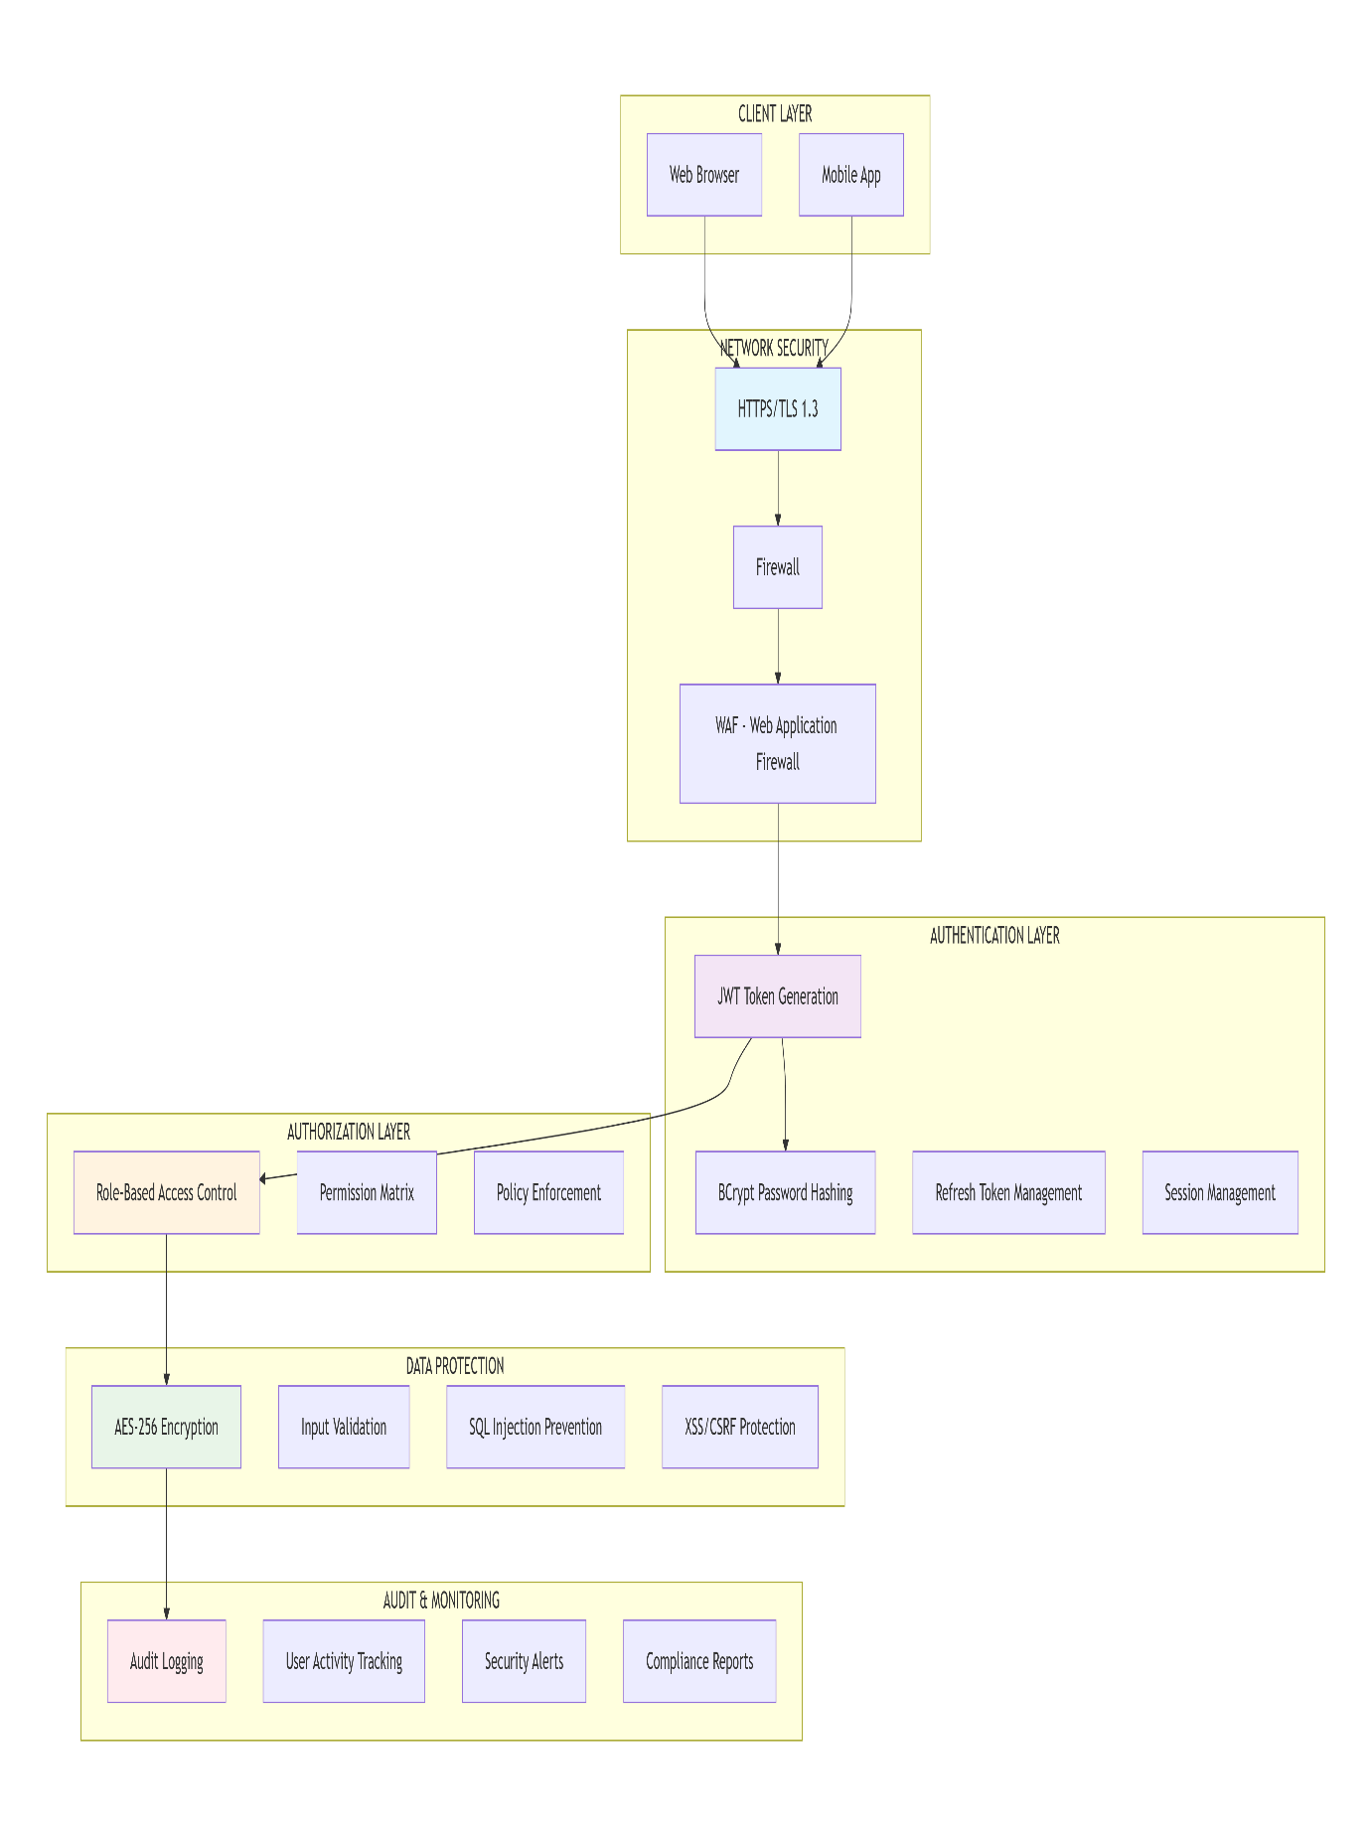

10.2 Authentication & Authorization Flow
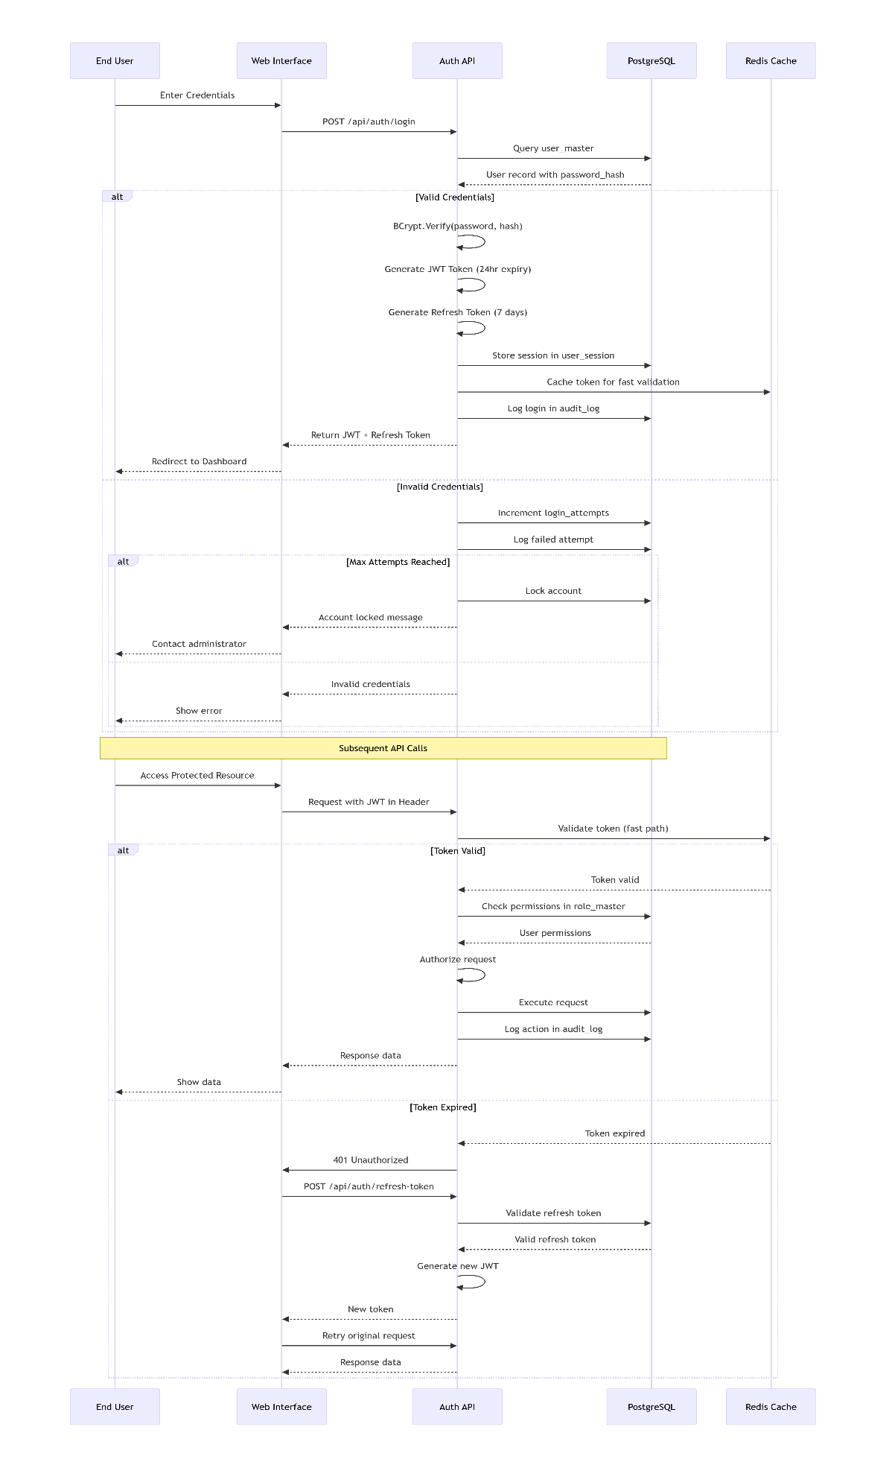
10.3 Role Based Access Control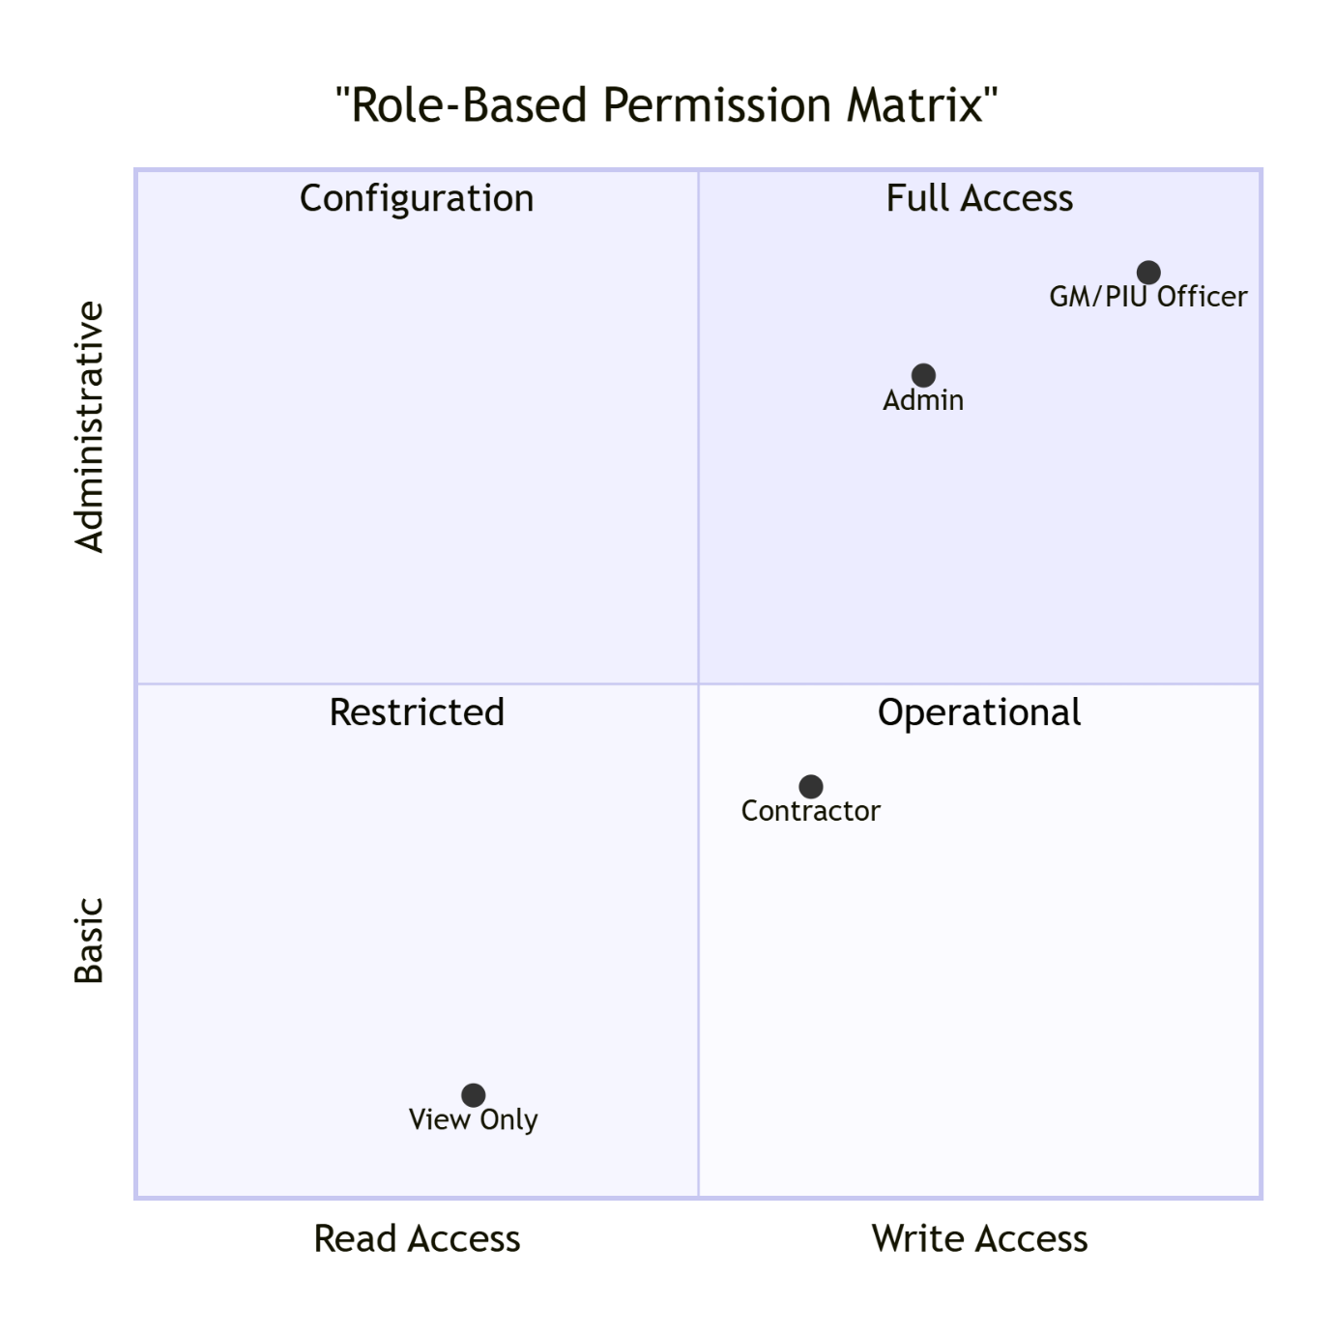

10.4 Permission Matrix Table:
Feature/Module | GM/PIU | Contractor | Admin
User Management | Read Only | No Access | Full Access
Contract Creation | Create/Edit/Delete | View Assigned | No Access
Bill Submission | Approve/Reject | Create/Submit | No Access
Report Generation | Full Access | Contract-specific | System Reports
Master Data | Read Only | No Access | Create/Edit
Audit Logs | View All | View Own | View All
System Settings | No Access | No Access | Full Access
10.5 Password Security Workflow: 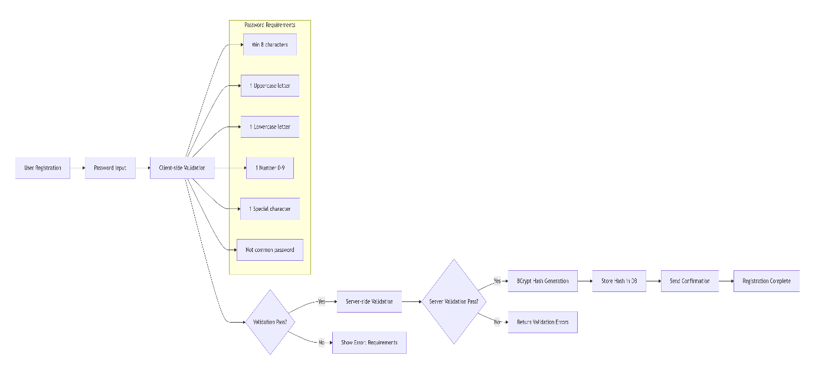

10.6 JWT Token Structure: 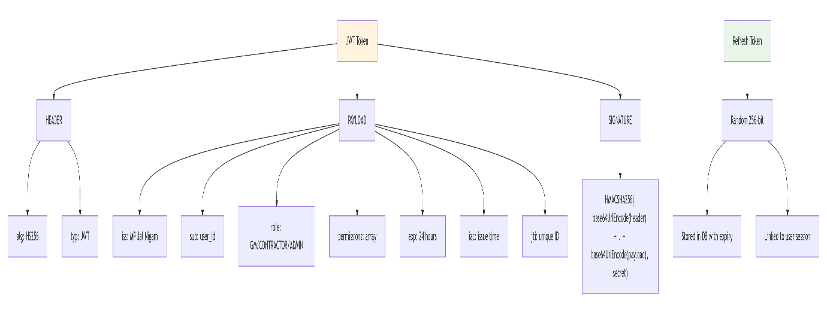
10.7 Data Encryption Architecture: 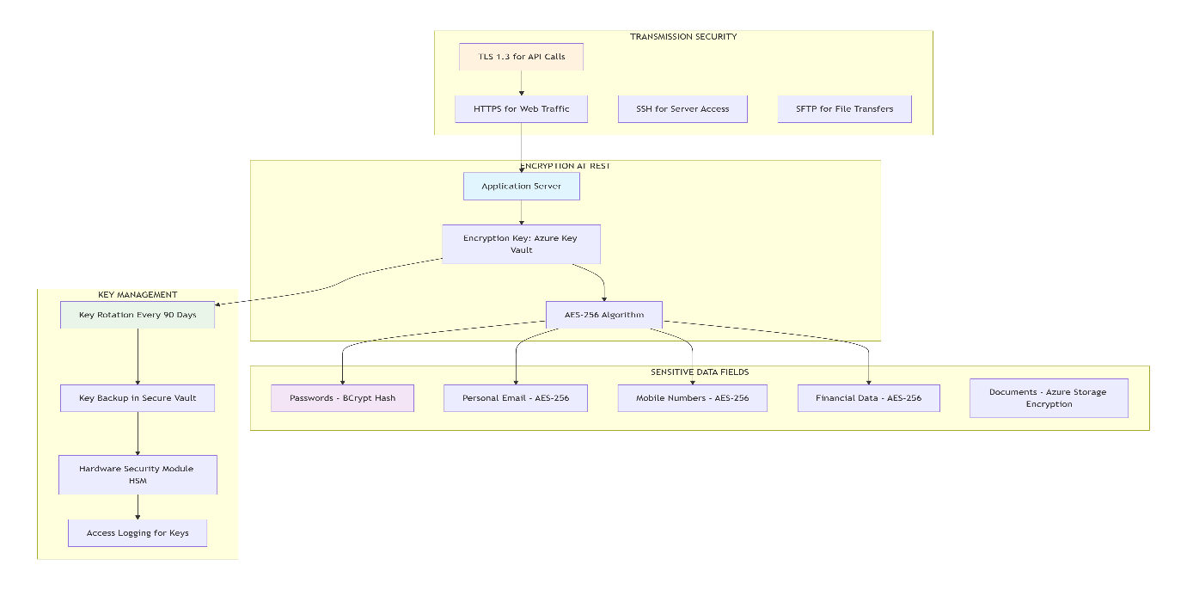

10.8 Audit Trail System: 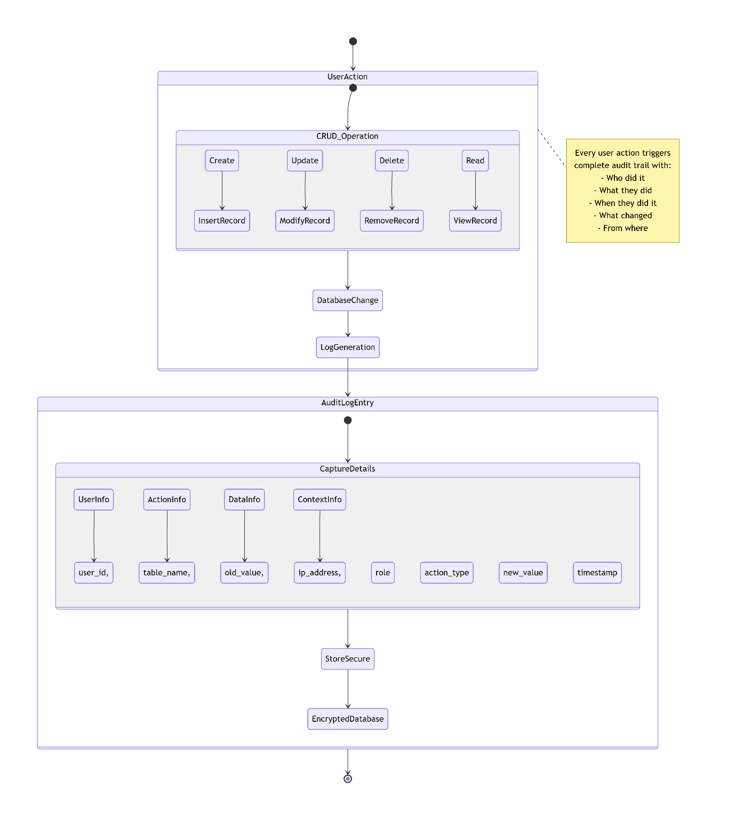

11. ERROR HANDLING & VALIDATION ARCHITECTURE
11.1 Error handling Flow:
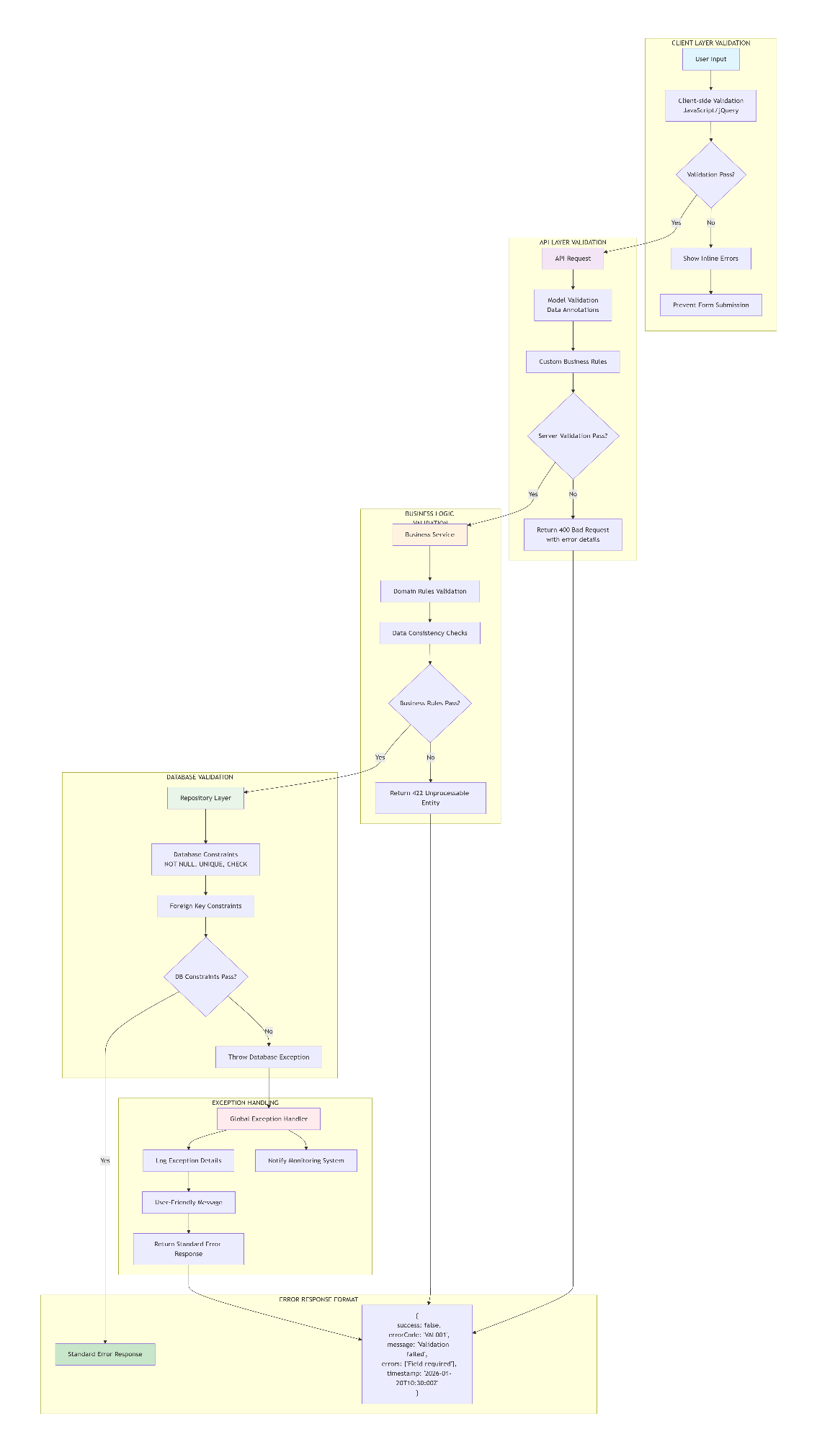
11.2 Validation Hierarchy: 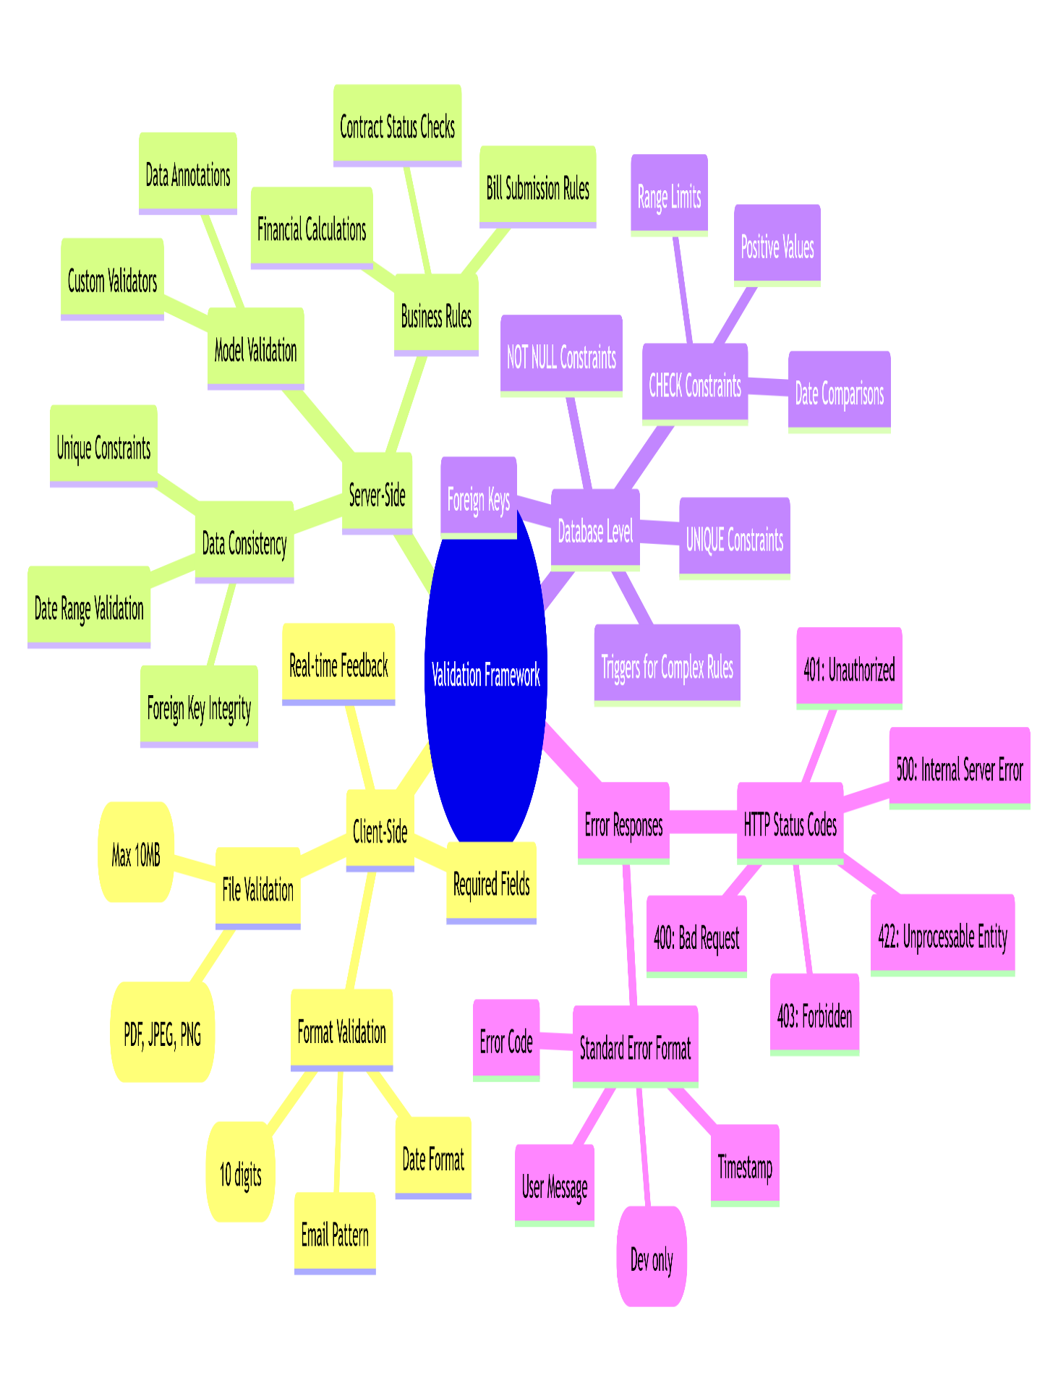

11.3 Error Categories & Handling:
Error Category | HTTP Status | Error Codes | Example | Handling Strategy
Validation Errors | 400 | VAL001-VAL999 | Required field missing | Show user-friendly message
Authentication Errors | 401 | AUTH001-AUTH099 | Invalid token | Redirect to login
Authorization Errors | 403 | AUTH100-AUTH199 | Insufficient permissions | Show access denied
Business Rule Errors | 422 | BUS001-BUS999 | Bill already submitted | Show specific business error
Data Not Found | 404 | DATA001-DATA099 | Contract not found | Show not found message
Database Errors | 500 | DB001-DB999 | Connection failed | Log & show generic error
External Service Errors | 502 | EXT001-EXT999 | Email service down | Retry & notify admin

11.4 Exception Handling:
Global Exception Handling Pipeline:
Step 1: Try-Catch in Controllers
Step 2: Action Filter Attributes
Step 3: Exception Handling Middleware
Step 4: Logging (Serilog + File + DB)
Step 5: User-Friendly Response
Step 6: Alert Notification (Critical Errors)

Middleware Order:
1. Request Logging
2. Authentication
3. Authorization
4. Validation
5. Business Logic
6. Exception Handling
7. Response Transformation

12. PERFORMANCE OPTIMIZATION & DEPLOYMENT CHECKLIST
12.1 Performance Architecture:
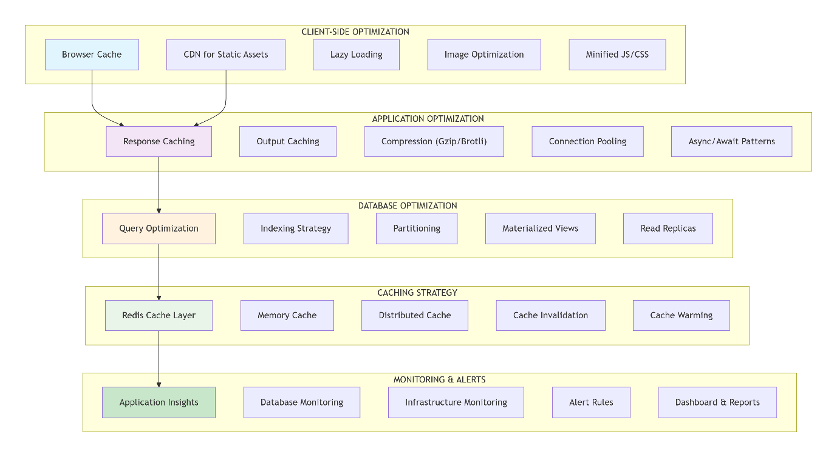

12.2 Performance Architecture Matrix:
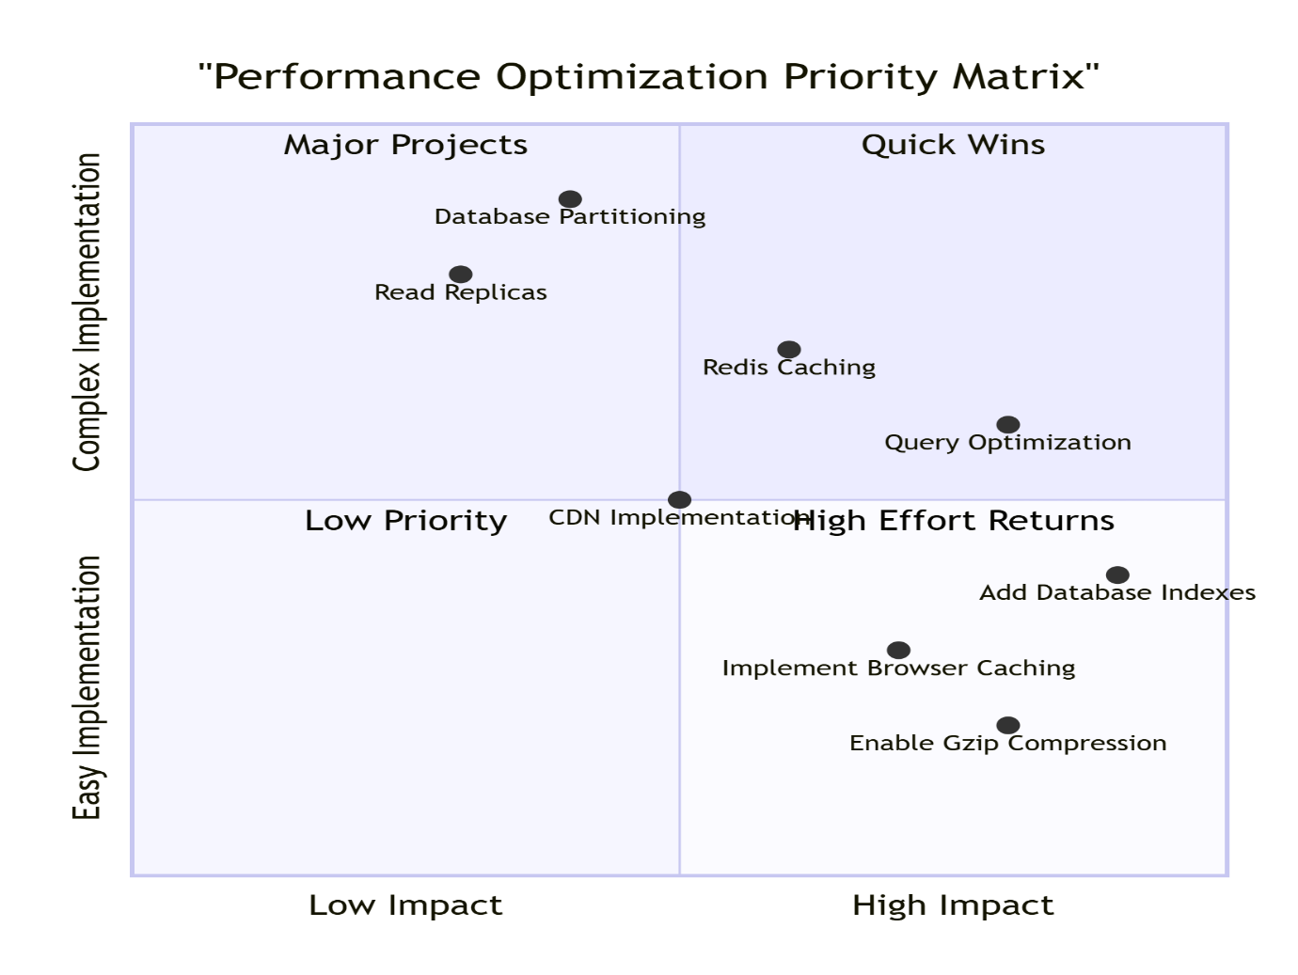

12.3 Deployment Checklist: 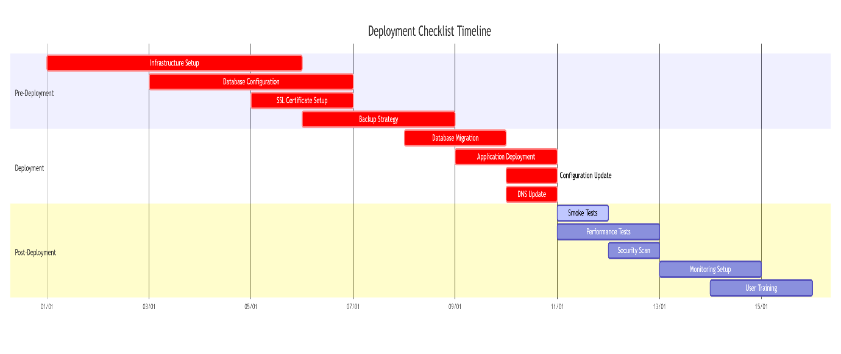

12.4 Scalability Strategy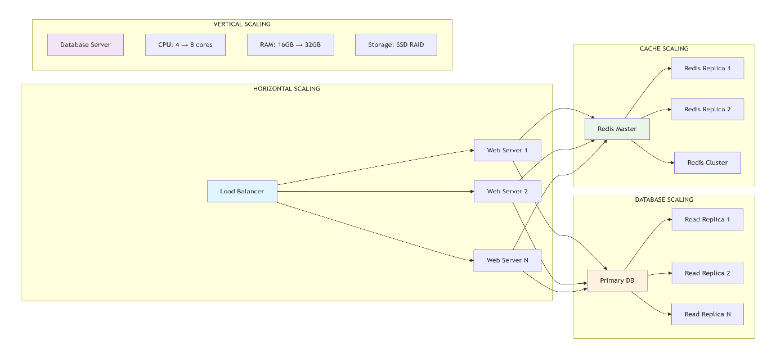12.5 Maintenance Scheduled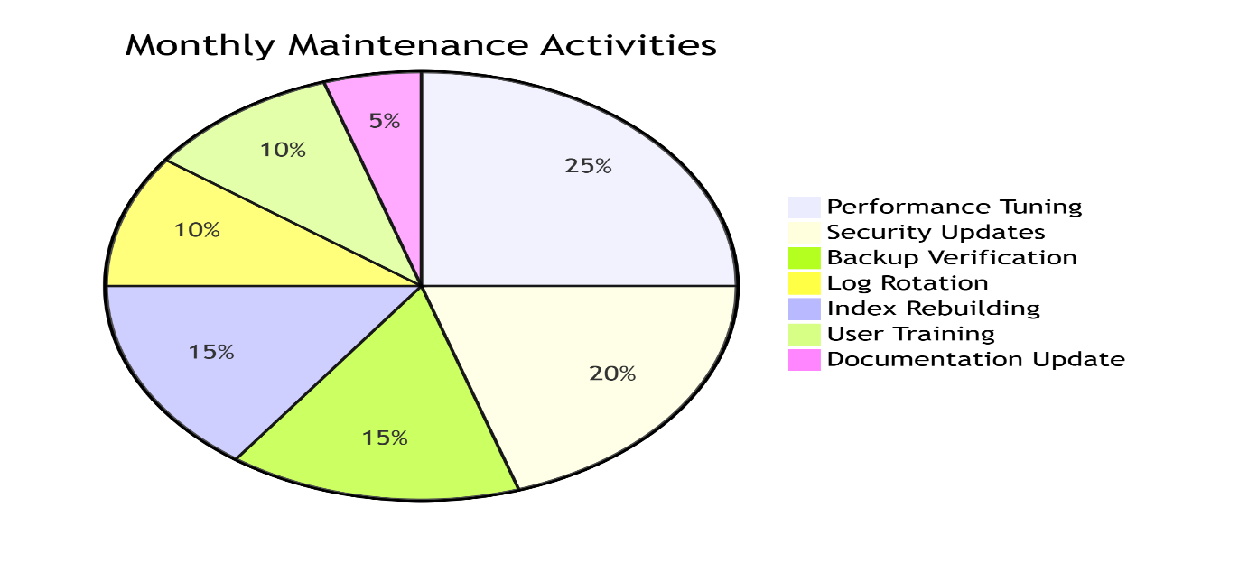

13. PROJECT IMPLEMENTATION ROADMAP
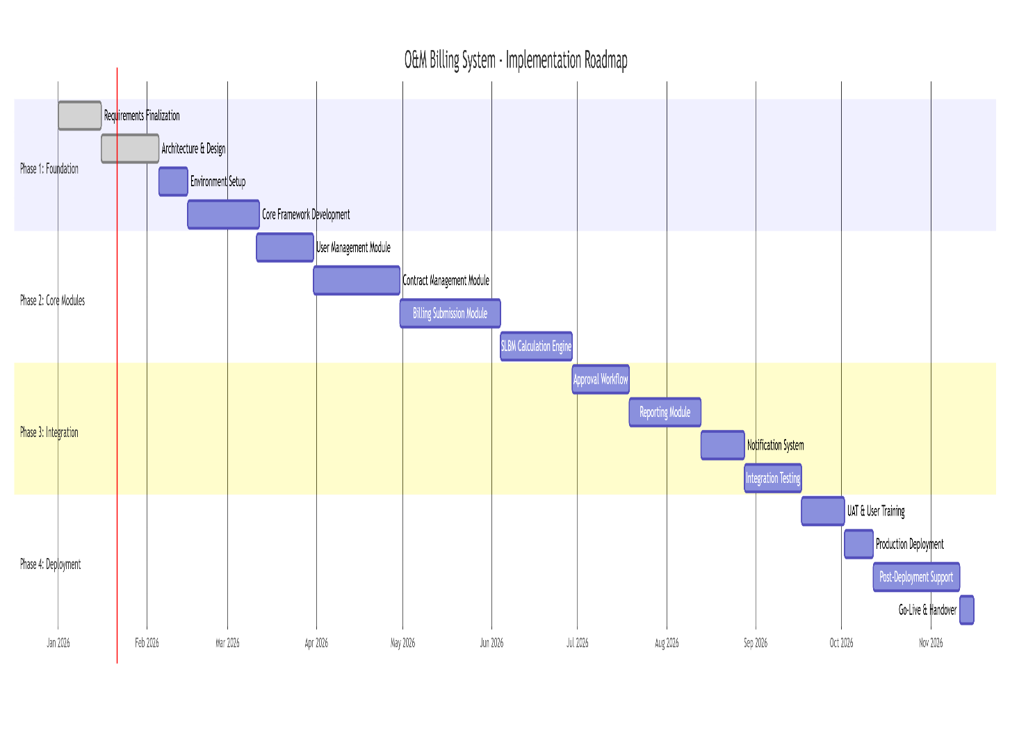
- SUCCESS METRICS & KPIs
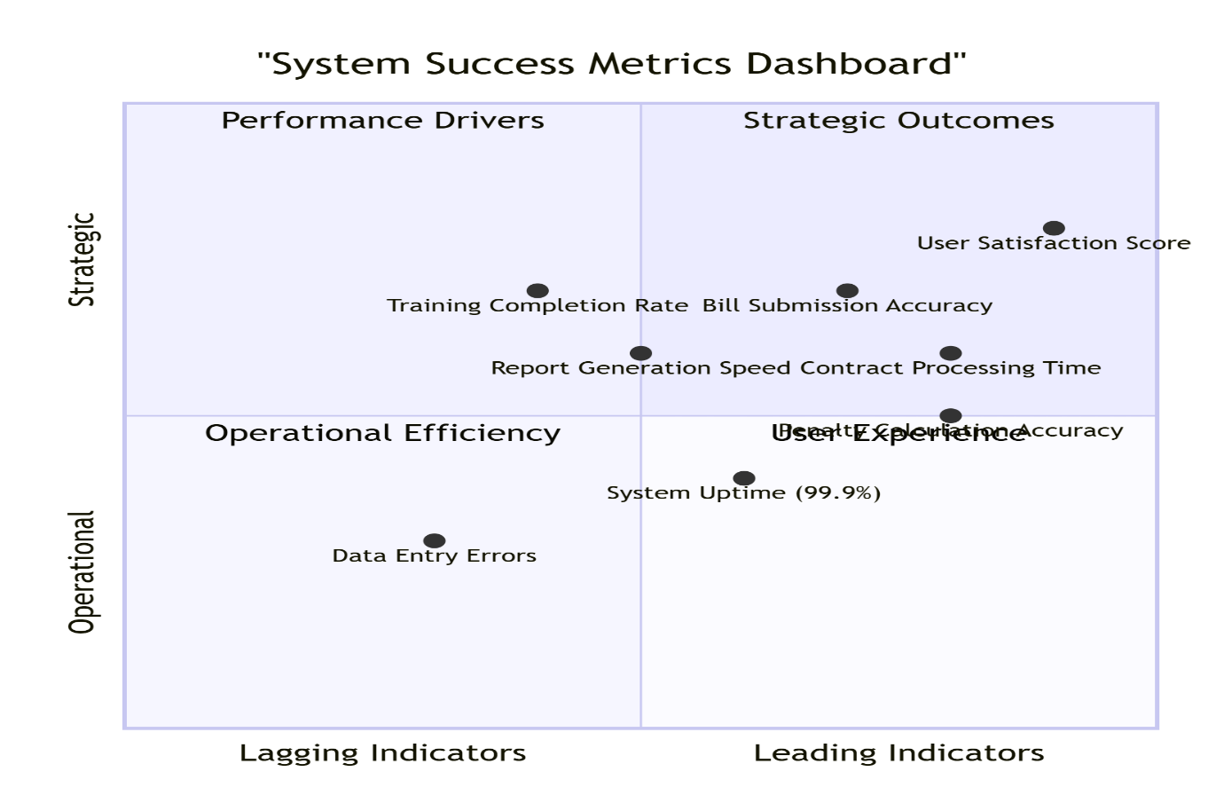

- RISK MANAGEMENT PLAN 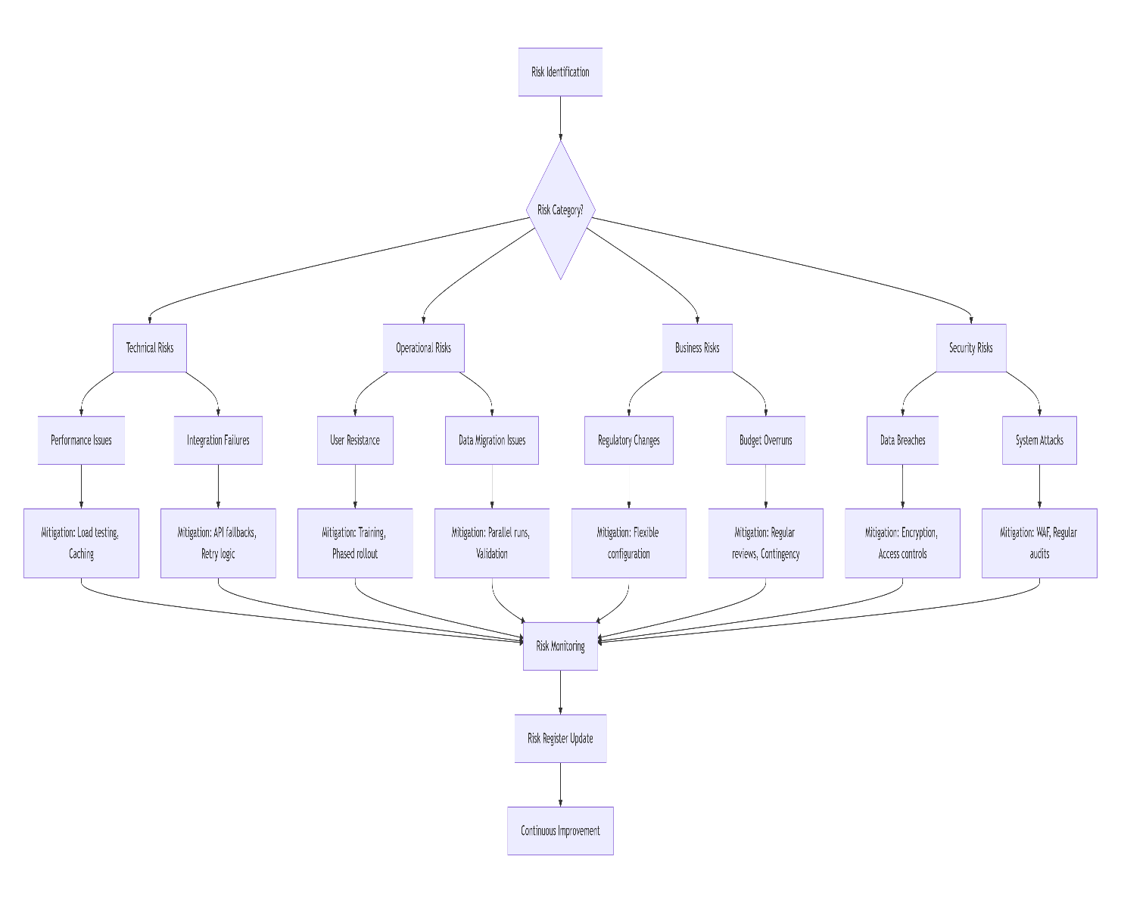
- TRANING & KNOWLEDE TRANSFER 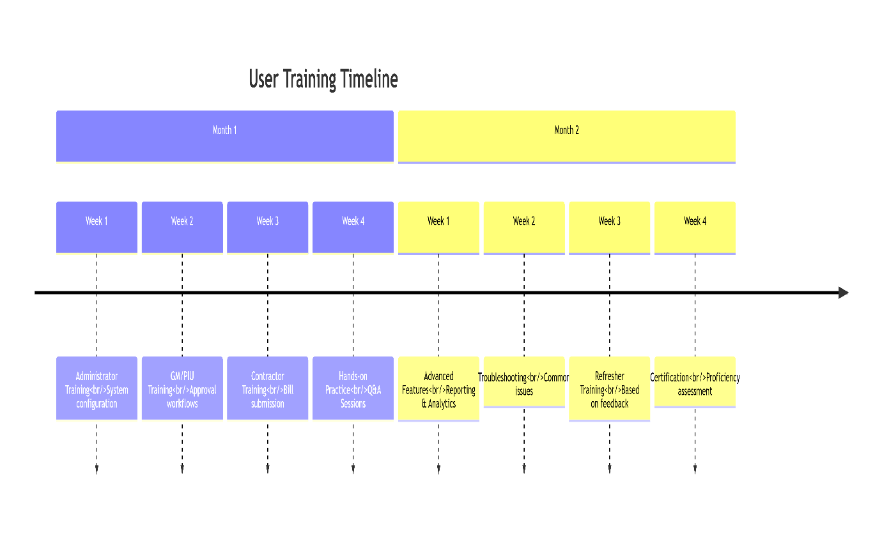
- FUTURE ENHANCEMENT 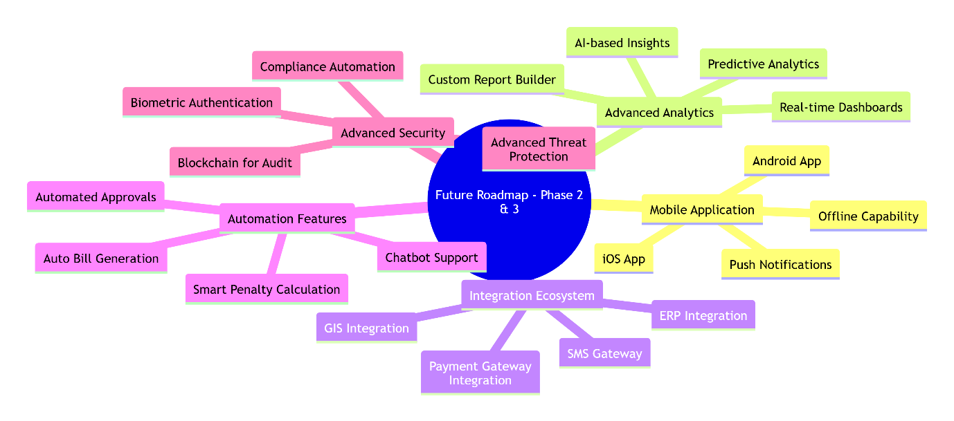

- FUTURE CLOSURE DOCUMENTATION
Document | Purpose | Audience
Final LLD Document | Complete technical reference | Development & Maintenance teams
User Manuals | End-user guidance | All system users
Administrator Guide | System administration | IT administrators
API Documentation | Integration reference | External developers
Deployment Guide | Installation procedures | Deployment team
Maintenance Manual | Ongoing support | Support team
Training Materials | User education | Training department
Source Code | Complete application code | Development team
Database Scripts | Schema & data scripts | Database administrators

- Acknowledgements
Project Teams:
Role | Organization | Responsibilities
Project Sponsor | MP Jal Nigam | Funding & strategic direction
Project Manager | MPSSDI | Overall project management
Technical Lead | MPSeDC | Technical architecture & design
Development Team | MPSSDI & MPSeDC | System development
QA Team | MPSSDI | Testing & quality assurance
Database Team | MPSeDC | Database design & optimization
Infrastructure Team | MP Jal Nigam IT | Server & network setup
Subject Matter Experts | MP Jal Nigam | Business requirements & validation

- CONTACT INFORMATION
20.1 Support Contacts:
For Technical Support:
Email: support.ombilling@mpssdi.gov.in
Phone: 0755-XXXXXXX (Ext. 123)
Hours: 9:00 AM - 6:00 PM (Monday-Saturday)

20.2 For Business Queries:
Email: ombilling@jalrekha.mp.gov.in
Phone: 0755-XXXXXXX (Ext. 456)
Emergency Support (24x7):
Phone: 0755-XXXXXXX (Emergency Hotline)

20.3 Escalation Matrix
Issue Type | Level 1 | Level 2 | Level 3
User Access Issues | Help Desk | Application Team | Security Team
System Performance | Help Desk | Infrastructure Team | Development Team
Data Issues | Help Desk | Database Team | Development Team
Security Incidents | Help Desk | Security Team | CISO Office
New Requirements | Business Team | Project Manager | Steering Committee

- DOCUMENT APPROVAL
Document Approval Status:
Prepared By:
- Name: Technical Team, MPSSDI & MPSeDC
- Date: January 20, 2026
- Signature: _________________
Reviewed By:
- Name: Project Manager, MPSSDI
- Date: January 22, 2026
- Signature: _________________
- Comments: "Document meets all technical requirements"
Approved By:
- Name: Managing Director, MP Jal Nigam Maryadit
- Date: January 25, 2026
- Signature: _________________
- Comments: "Approved for implementation

Distribution List:
- Development Team
- Database Team
- QA Team
- Infrastructure Team
- Business Stakeholders
- Project Management Office

- FINAL SIGN OFF
Project Completion Checklist:
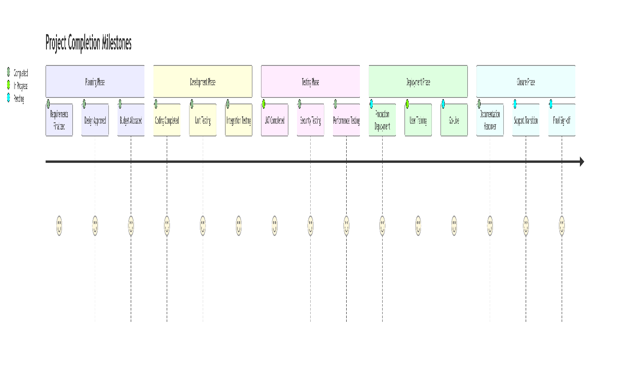

- O&M BILLING SYSTEM - ACTUAL SOFTWARE FLOW SCREENSHOTS
LOGIN & DASHBOARD

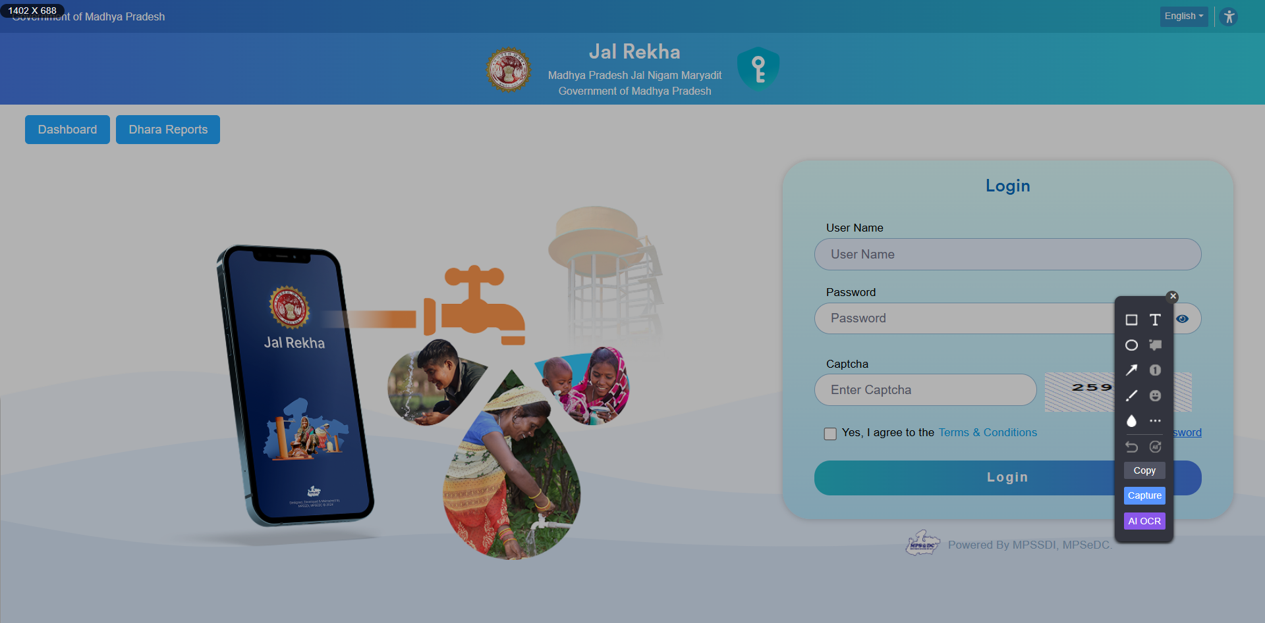

Dashboard - GM/OM (Basic Details)
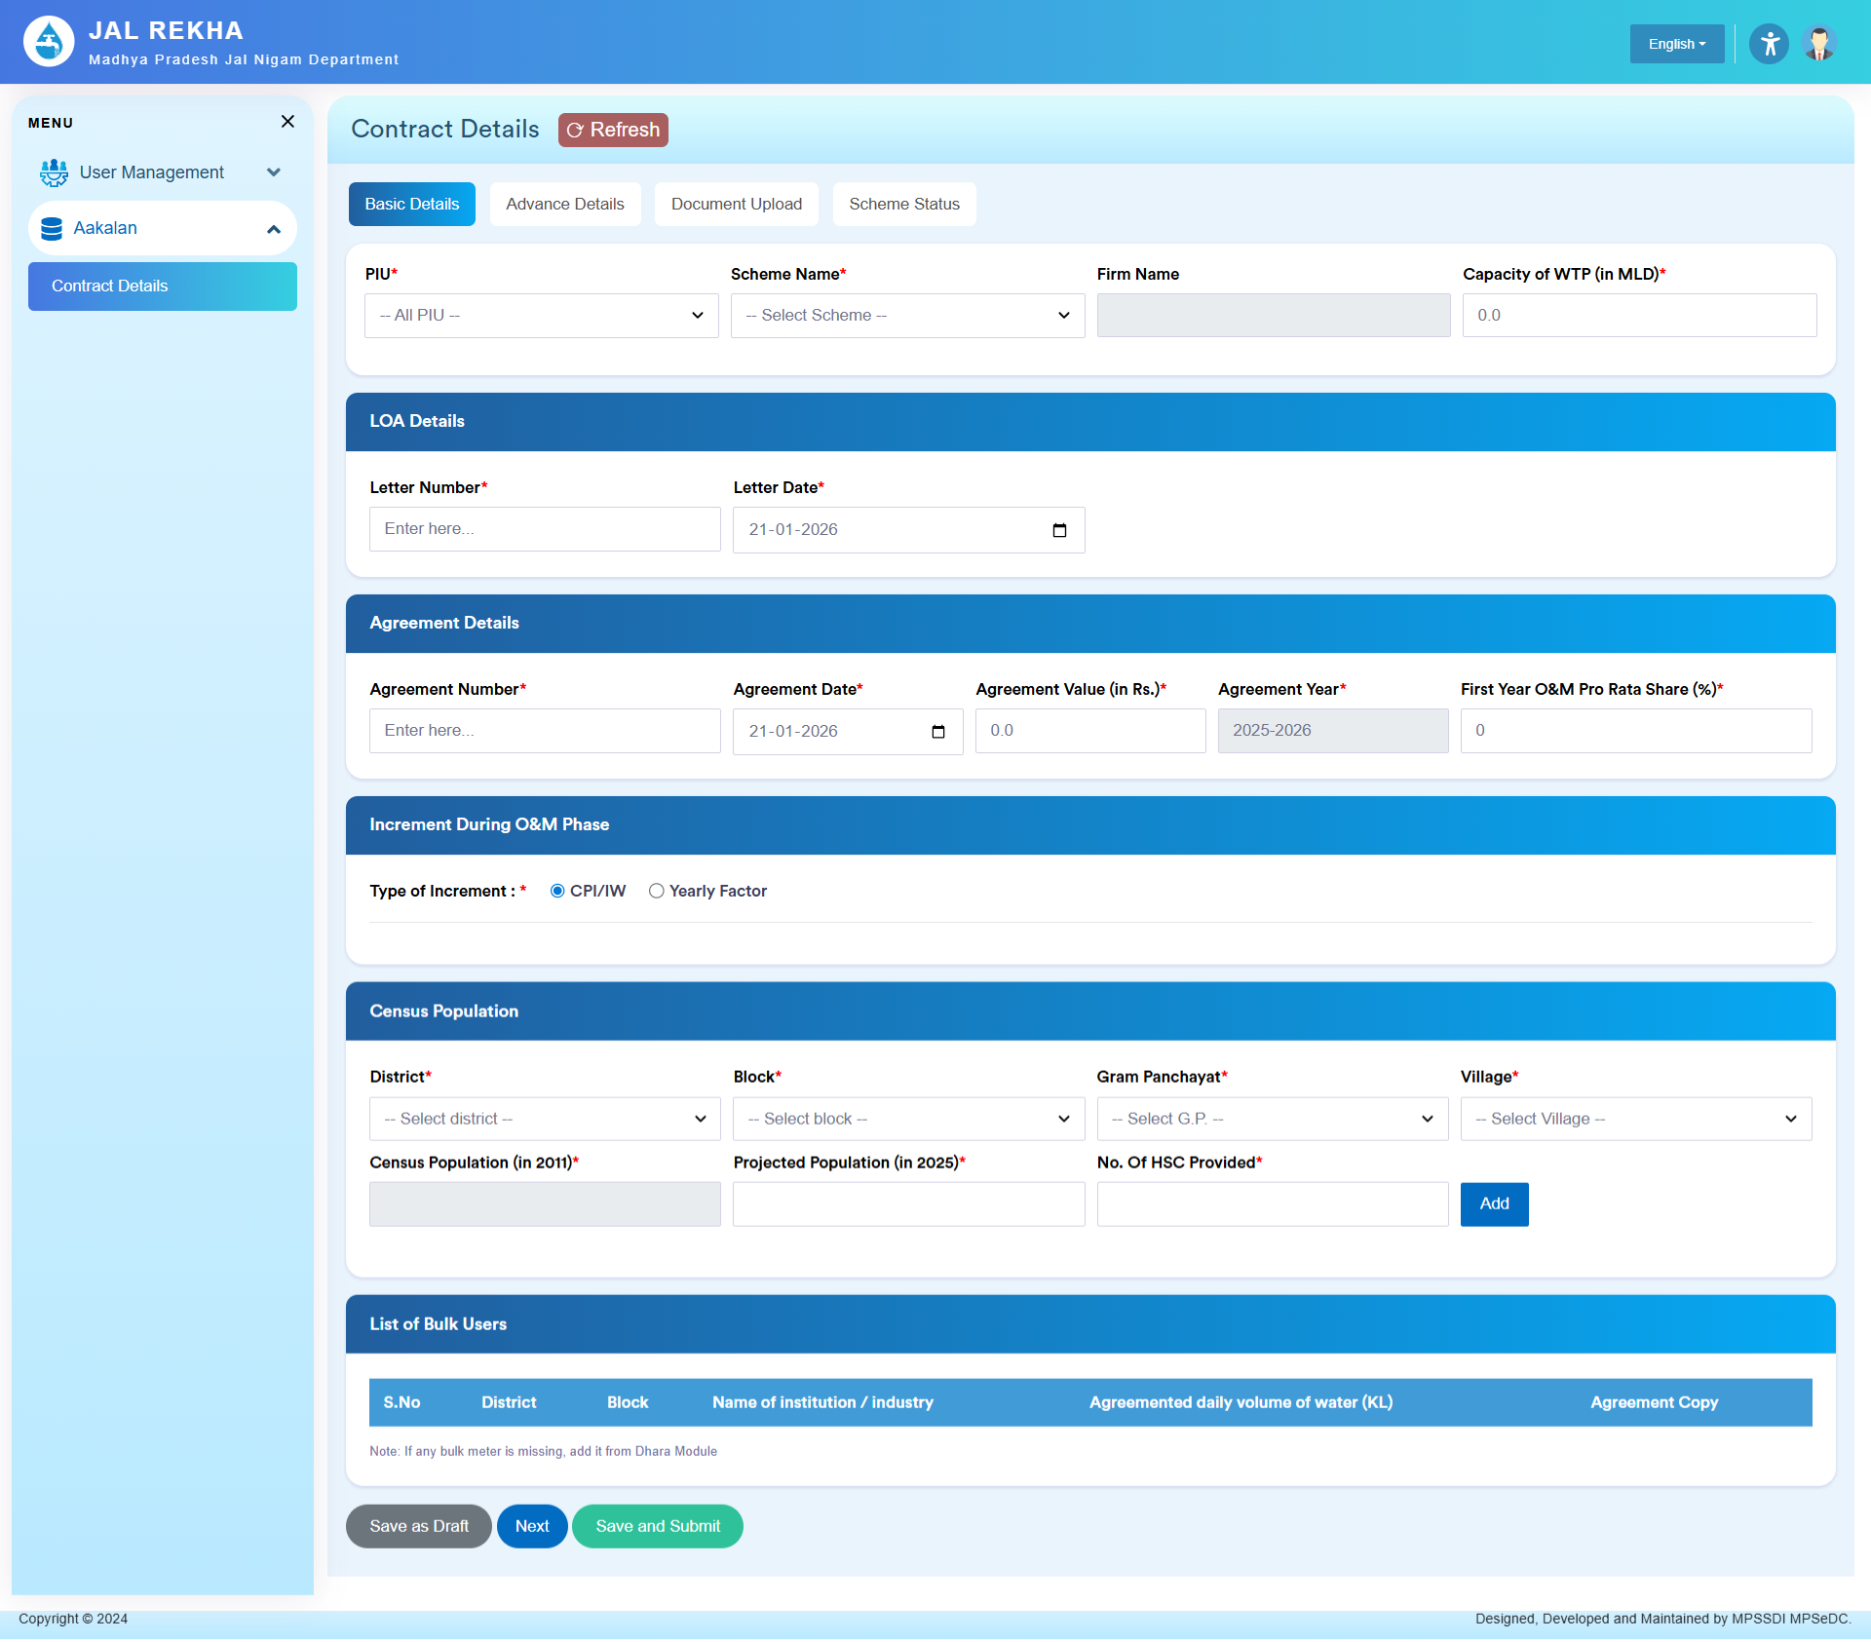

Dashboard - GM/OM Advanced Details (SLBM Penalty)
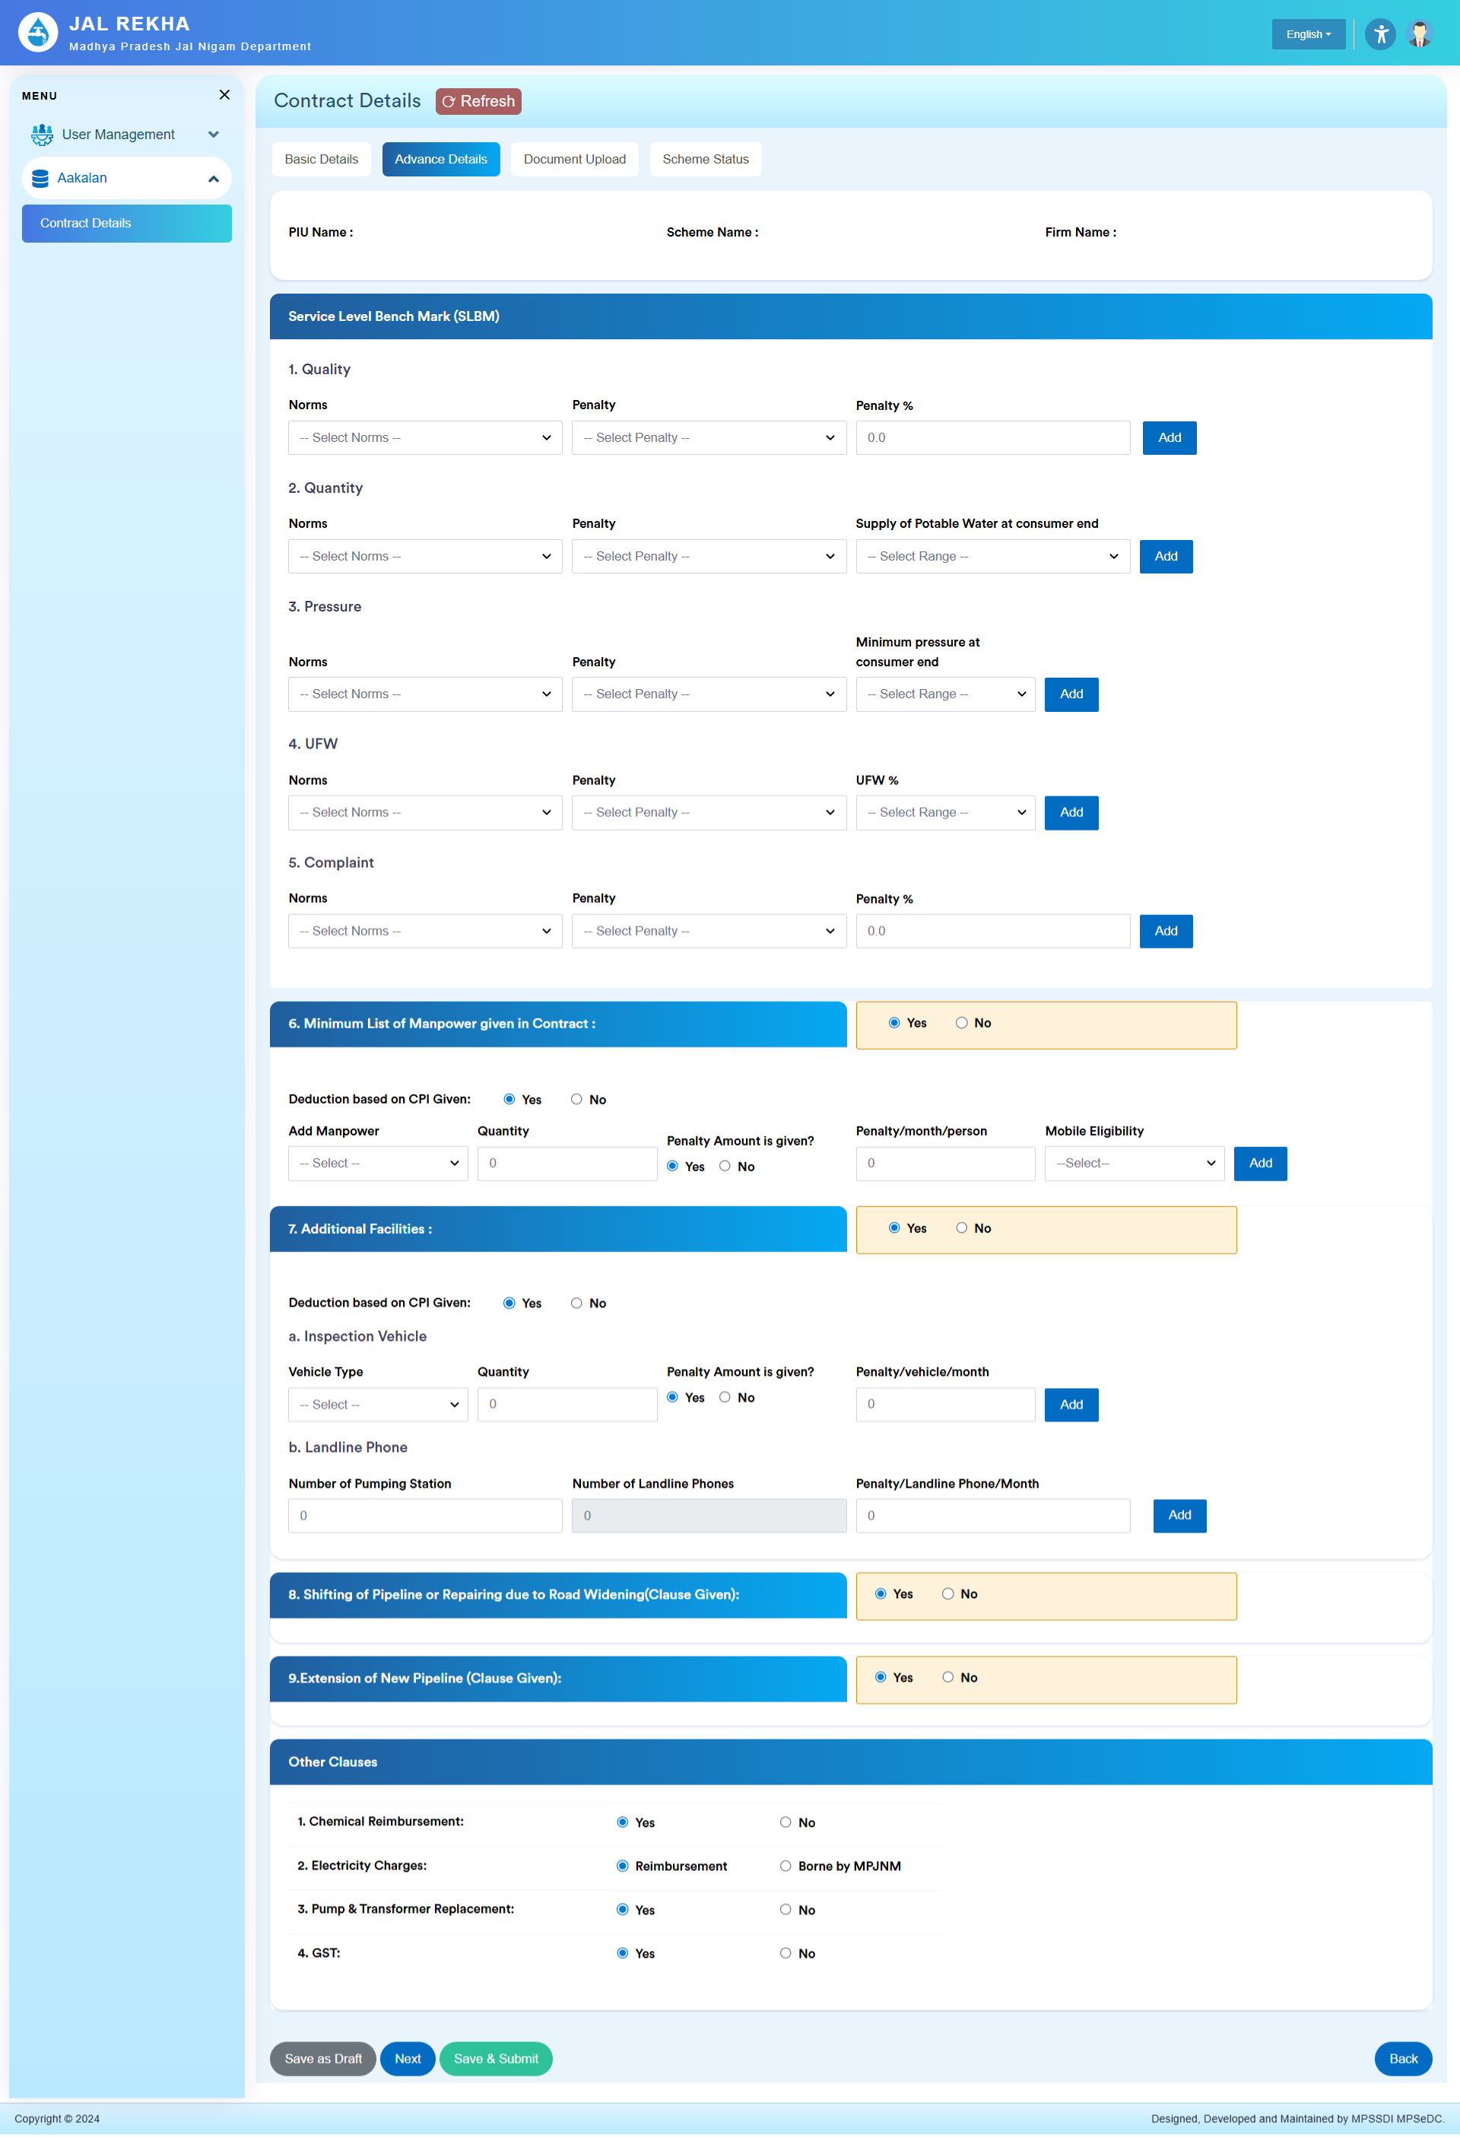
Dashboard - GM/OM Documents Uploads
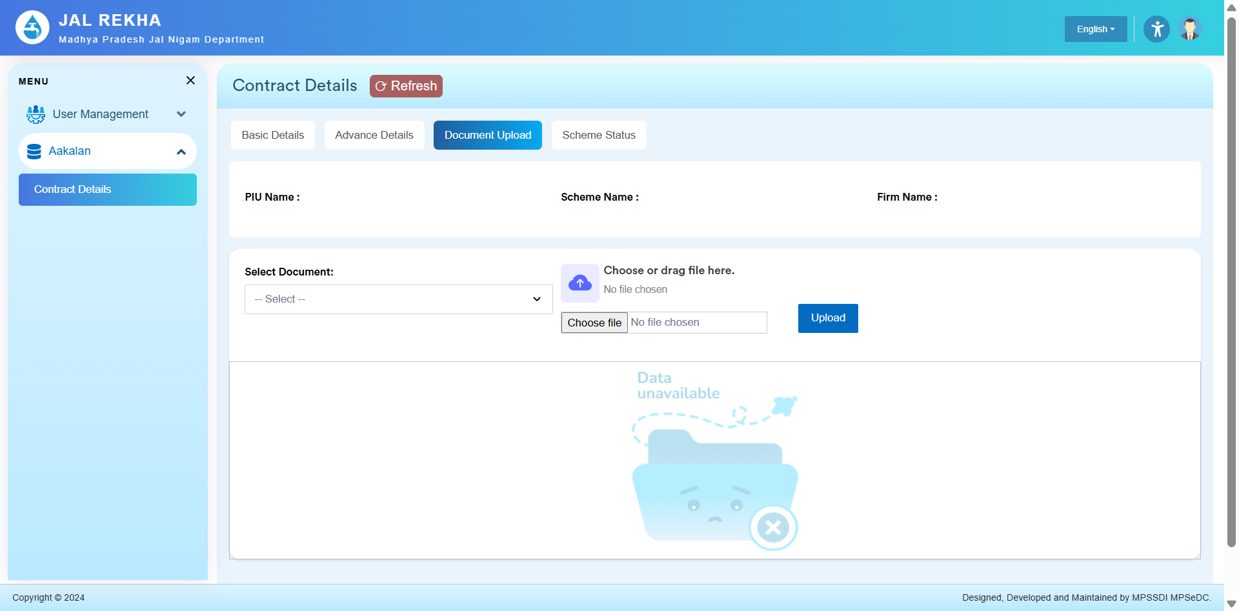

Dashboard - GM/OM Scheme Status(OM Date & Trial Run Date)

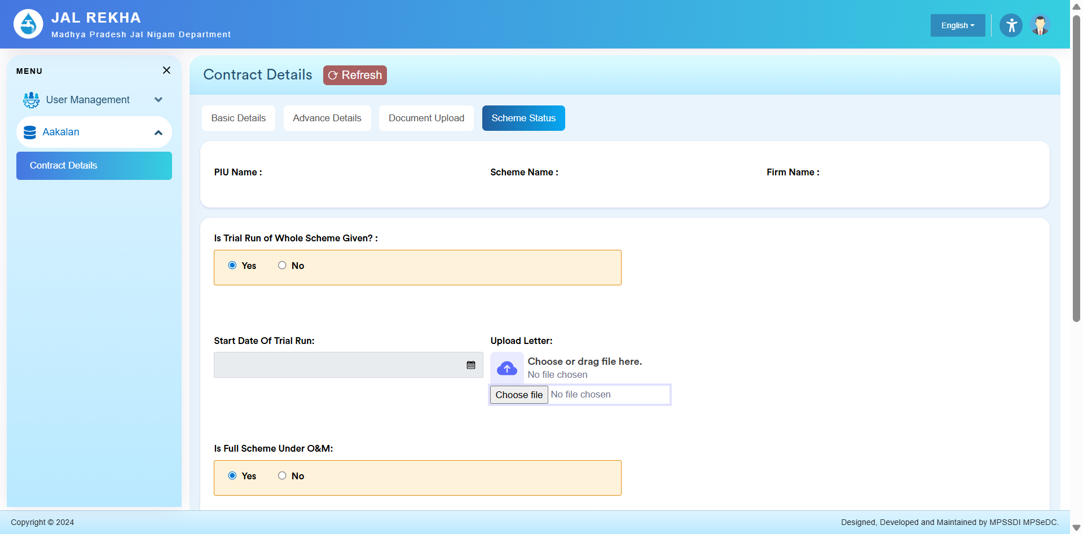

Dashboard - Contractor Login


Dashboard - Contractor RA Bill Generate (Yearly & CPI Based)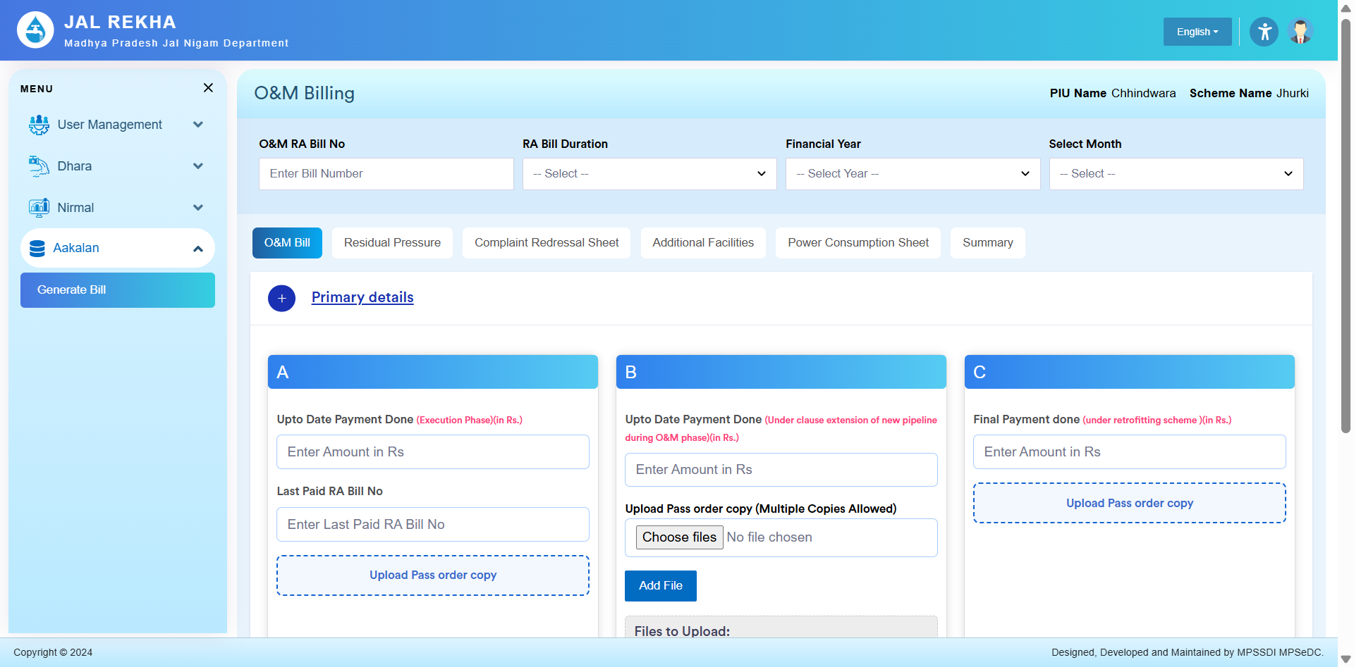
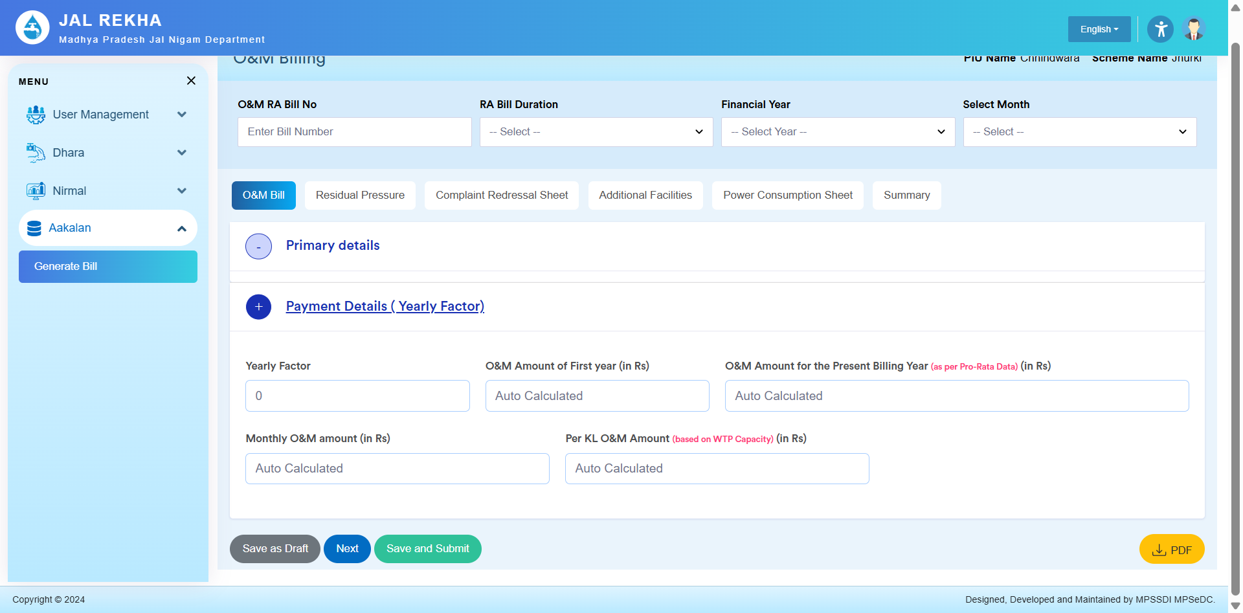

Contractor Residual Pressure (Village Wise)
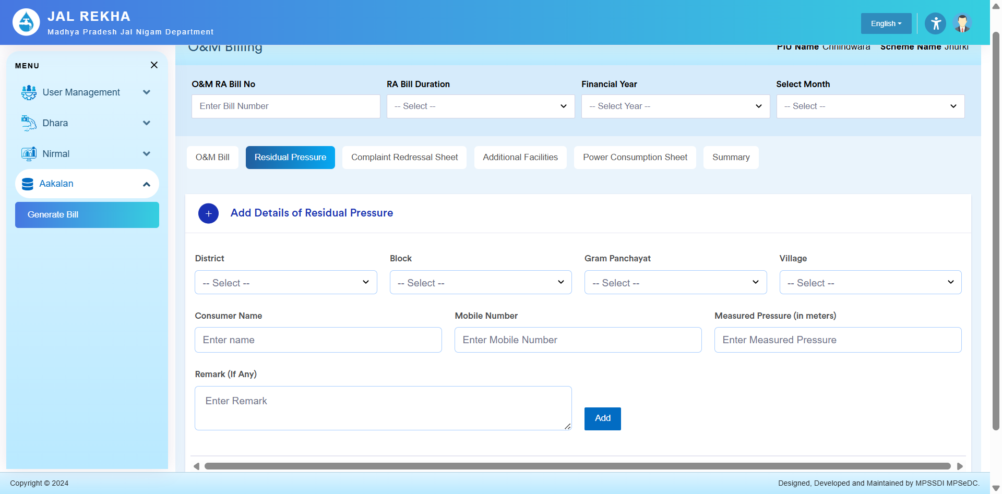

Complaint Redressal Sheet (Village Wise) 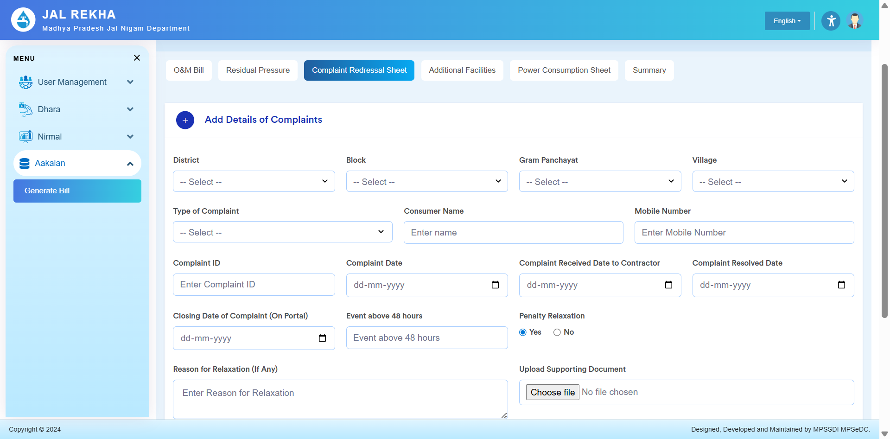
Additional Facilities (Manpower & Village & Landline) 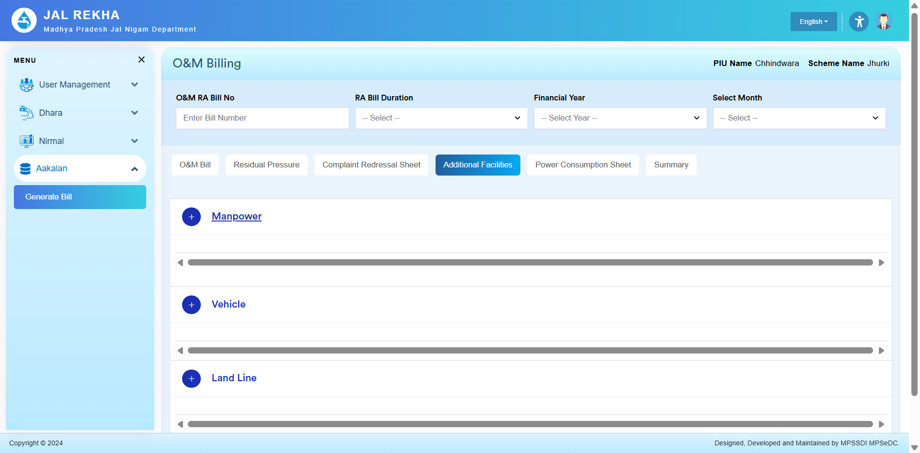

Power consumption (For Calculations in Dhara, OHT, Bulk User)
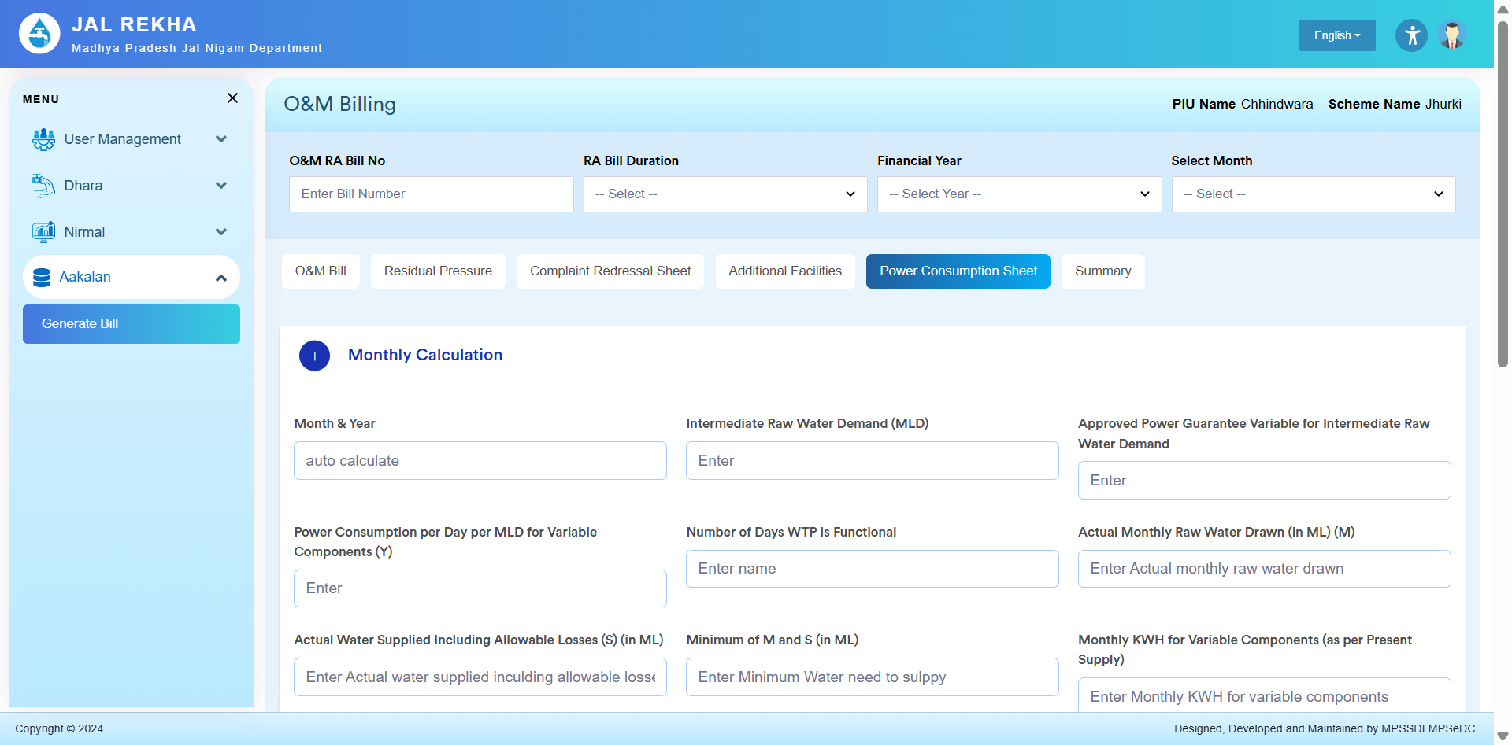

Summary Page (For Calculations in Dhara, OHT, Bulk User, Village, All Penalties Etc)
